**EXPERIMENT-1**

### AIM: Demonstration and study about different physical equipment used for networking; NIC (Network Interface Card), types of cable, Fiber Optics

### Learning Objective:

At the end of the session you will be able to become familiar with different types of equipment’s and cables used in the networked lab.

### What is a Computer Network?

Computer network means an interconnected collection of autonomous computers. Two computes said to be connected if they are able to exchange information. The connection needs to be done via some transmission media such as a coaxial cable, twisted pair cable; fiber optics, microwaves and communication satellite can also be used. To interconnect the devices in the network requires some networking devices such as a hub, a switch or a router etc. To be autonomous means a device to be able to start or stop of its own.

### Benefits of Computer network:

* Resource Sharing
* High Reliability
* Saving Money

### Network Components

* + 1. **Server**

Concept of a server is based on one or more personal computers to perform specific tasks for a number of other PCs. The most common function is disk, file and print servers.

A **Disk Server** provides low-level support and performs basic read/write operation to disk sectors.

A **File Sever** is a higher-level support mechanism, performing such function as lockout and dynamic allocation of space on disk. In a star topology the server is the principal connection point. All nodes, including the server, are connected to a hub. This enables the server to house and administer software, fie sharing, file

saving and to allocate printers or other peripherals. In a bus topology, the server acts like arbitrator, each node talks to the server when requesting information. The server then locates the information on one of the connected clients and sends it to the requesting client. Servers in any network can be an ordinary node but having more capabilities of handling the data and having more speed.

### Workstation

A node or stand-alone PC that is connected with network is called Workstation. A workstation is generally a Client.

**NIC (Network Interface Card):** The network Interface Card (NIC) is the interface between the PC and physical network connection. It is also called as Network Adapter Card. The NIC is responsible for the operation that tasks place in the physical layer of the OSI model. It is only concerned with sending and receiving) 0s and 1s, using the IEEE 802.3 Ethernet standard.

In windows, the NIC card is identified in the network property; to use protocol with NIC you must bind the protocol to the adapter card.

### Function of NIC:

* 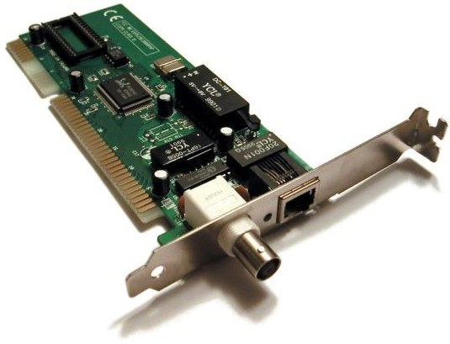Data Transfer
* Data Buffering
* Frame Construction
* Media Access Control
* Parallel/Serial Conversion
* Data Encoding/Decoding
* Data Transmission/Reception

### Cables

To transmit the data the medium must exist, usually in the form of cables or wireless media. Here are some most commonly used cable types.

### Thick Coaxial Cables (thick net) (RG-11)

Thick coaxial cables or thick wire is known as the Ethernet standard RG-11. This cable is mostly used as backbone cable, distributing Ethernet signal throughout a building, an office complex or other large installation. It is used in 10base5 Ethernet standard. The length may be up to 500 meters with a max of

five segments connected by repeaters. This gives a total distance of 2500 meters. This is called a network diameter. RG-11 cable is typically orange; with black rings around the cable every 2.5-meter to allow taps into the cable.

### Thin coaxial cables (thin net) (RG-58)

RG-58 is typically used for wiring laboratories and offices, or another small group of computers. The maximum length of thin wire Ethernet segment is 185 meters, which is due to the nature of the CSMA/CD method of operation, the cable attenuation, and the speed at which signals propagate inside the coax.

*Fig: Thin coaxial cables (thin net) (RG-58)*

The length is limited to guarantee that collision is detected when machines that are apart transmit at the same time. BNC connectors are used to terminate each end of the cable. When many machines are connected to the same Ethernet segment, a daisy chain approach is used. The BNC connectors allow the network interface card to the next machine. The machine each end of the cable must use a terminating resistor to eliminate collision-causing reflection in the cable.

### Coaxial Cable Connectors

Coaxial connectors are needed to connect coaxial cable to devices. The most common type of connector used today is the Bayone-Neil-Concelman, in short, BNC connector.

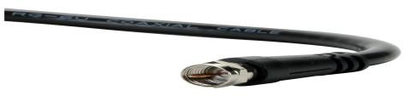

*Coaxial Cable Connector*

The three popular types of connectors are: the BNC connector, the BNC T connector, and the BNC terminator. The BNC connector is used to connect the end of the cable to a device, such as a TV set. The BNC T connector is used in Ethernet networks to branch out to a connection to a computer or other device.

The BNC terminator is used at the end of the cable to prevent the reflection of the signal.

### Applications

* + - * 1. Coaxial cable was widely used in analog telephone networks, and later with digital telephone networks.
        2. Cable TV networks use coaxial cables (RG-59) at the network boundaries. However, coaxial cable has largely been replaced today with fiber-optic cable due to its higher attenuation.
        3. Traditional Ethernet LAN

10Base-2, or thin Ethernet, uses RG-58 coax cable with BNC connectors.

10Base-5, or thick Ethernet, uses RG-11 coax cable with specialized connectors.

### Twisted pair cables

Twisted pair is probably the most widely used cabling system in Ethernet in networks. Two copper wires twist around each other to form the twisted pair cable. Depending on category several insulated wire strands can reside in the cable.

### Twisted pair is available in two basic types

1. Unshielded Twisted Pair (UTP)
2. Shielded Twisted Pair (STP)

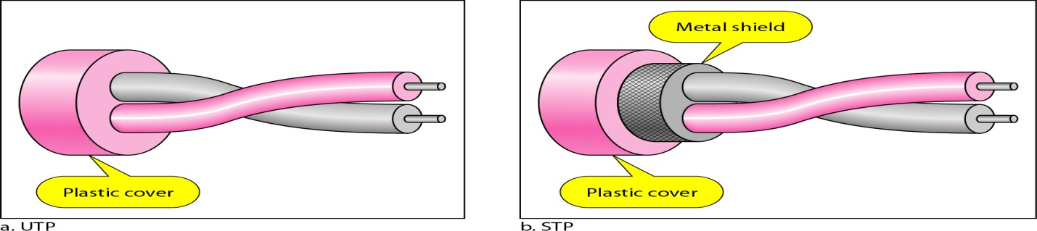

*Fig: Twisted pair cables*

### Unshielded Twisted Pair

Mostly the UTP is used. A twisted pair segment can’t exceed 100 meters. This limitation is the only drawback to twisted pair. Twisted pair is used for 10/100 based Ethernet networks. UTP cables are wired as straight through or crossover cables. Straight through cables typically connect the computer’s networks interface can’t to be a port on the hub. Crossover cables are used for NIC to

communication and for hub-to-hub connections when no crossover port is available.

|  |  |
| --- | --- |
| **Category** | **Descriptor** |
| 1 | Used for voice for data. |
| 2 | Contains four twisted pair and a data transmission up to 4 Mbps.  Used for some token ring network. |
| 3 | Contains four twisted pair and a data transmission up to 10 Mbps.  Used for some token ring network. |
| 4 | Contains four twisted pair and a data transmission up to 16 Mbps.  Used for some token ring network. |
| 5 | Contains four twisted pair and a data transmission up to 100 Mbps.  Used for some token ring network. |

**Category-5** cables can be purchased or crimped as either straight through or crossed. A category-5 cable has 8 thin. Colours coded wires inside that run from one end of the cable to the other. Ethernet networks for communication use only wires 1, 2, 3 and to be connected in both jacks. Straight through cables are used for connecting to a hub. Crossed cables are used for connecting a hub to another hub (there is an exception: some hubs are a built in uplink port that is crossed internally, which allows you to uplink hubs with a straight cable instead.) In a straight through cable wires 1, 2, 3…. and 6 at the other end. In a crossed cable, one order of the wires change from one end to the other wire 1 becomes 3 and 2 becomes 6.

**For PC 2 PC Communication without HUB (Cross Cable Connection)**

|  |  |  |  |
| --- | --- | --- | --- |
| Sl. No. | One Site | Second Site | Pin Configuration |
| 01 | Orange White | Green White | Transmit |
| 02 | Orange | Green | Transmit |
| 03 | Green White | Orange White | Receive |
| 04 | Blue | Blue | Not Use |
| 05 | Blue White | Blue White | Ground |
| 06 | Green | Green | Receive |
| 07 | Brown White | Brown White | DTR |
| 08 | Brown | Brown | DTS |

**For PC 2 PC Communication with HUB (Simple Cable Connection)**

|  |  |  |  |
| --- | --- | --- | --- |
| Sl. No. | One Site | Second Site | Pin Configuration |
| 01 | Orange White | Orange White | Transmit |
| 02 | Orange | Green | Transmit |

|  |  |  |  |
| --- | --- | --- | --- |
| 03 | Green White | Orange White | Receive |
| 04 | Blue | Blue | Not Use |
| 05 | Blue White | Blue White | Ground |
| 06 | Green | Green | Receive |
| 07 | Brown White | Brown White | DTR |
| 08 | Brown | Brown | DTS |

**For One Cable in Two PC Communication through HUB (Simple Cable Connection)**

**First Connection**

|  |  |  |  |
| --- | --- | --- | --- |
| Sl. No. | One Site | Second Site | Pin Configuration |
| 01 | Orange White | Green White | Transmit |
| 02 | Orange | Orange | Transmit |
| 03 | Green White | Green White | Receive |
| 04 | Green | Green | Receive |

**Second Connection:**

|  |  |  |  |
| --- | --- | --- | --- |
| Sl. No. | One Site | Second Site | Pin Configuration |
| 01 | Blue | Green White | Transmit |
| 02 | Blue White | Orange | Transmit |
| 03 | Brown White e | Green White | Receive |
| 04 | Brown | Green | Receive |

**Shielded Twisted Pair** It is 150Ω cable containing additional shielding that protects signals against electromagnetic Interference (EMI) produced by electric motors power lines etc. It is primarily used in Token Ring Network & where UTP cable would provide insufficient protection against interface. Wires within cables are encased in a metallic sheath that is conductive as copper in wires. This sheath when properly grounded converts it ambient noise into current, like antenna. This current is carried to wires within where it creates an equal and opposite current flowing in twisted pair thus getting cancelled and no noise signal is resulted.

### Unshielded Twisted-Pair Connector

The most common Unshielded Twisted-Pair connector is RJ45. RJ stands for registered jack.

Inside the Ethernet cable, there are 8 color coded wires, with all eight pins used as conductors. These wires are twisted into 4 pairs and each pair has a common

color theme. RJ45 specifies the physical male and female connectors as well as the pin assignments of the wires.

RJ45 uses 8P8C modular connector, which stands for 8 Position 8 Contact. It is a keyed connector which means that the connector can be inserted only in a single way. RJ45 is used almost exclusively to refer to Ethernet-type computer connectors.

### Characteristics of twisted pair cable

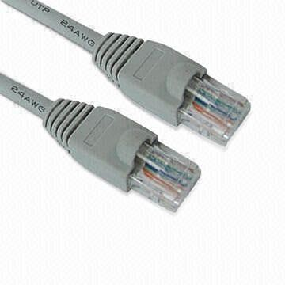

*Fig: Unshielded Twisted-Pair Connector*

1. Requires amplifiers every 5-6 km for analog signals
2. Requires repeaters every 2-3 km for digital signals
3. Attenuation is a strong function of frequency
4. Susceptible to interference and noise

### Applications

1. Used in telephone lines to provide voice and data channels.
2. The local loop –the line connecting the subscriber to the central telephone office- commonly consists of UTP cables.
3. DSL lines are also UTP cables.
4. LANs such as, 10Base-T and 100Base-T use UTP cables.

### Fibre Optic.

Fibre Optic relies on pulsed as light to carry information. Two types of plastic or glass with different physical properties are used (the inner core and the outer cladding) to allow a beam of light to reflect off the boundary between the core and cladding. Some fibre optic cables allow many different paths other allow one single mode. They are called multimode and single mode fibres. A popular multimode fibre has core/cladding dimensions of 62.5/125 nanometres.

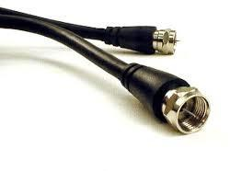

*Fiber Optic cable connector*

# EXPERIMENT-2

### Aim: Demonstration and study different internetworking devices in a computer network; Repeater Bridge, Router, Gateway, Hubs, Switches.

* 1. **Learning Objective:** At the end of the session you will be able to be familiar with different types of internetworking devices and their functions.

## REPEATER

A Repeater is a purely electrical device that extends maximum distance a LAN cable can span by Amplifying signals passing through it. A Repeater connects two segments and broadcasts packets between them. Since signal loss is a factor in the maximum length of a segment, a Repeater is used to amplify the signal and extend the usable length.

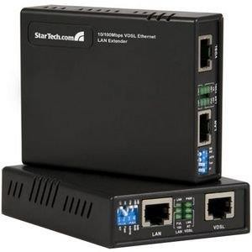

*Repeaters*

A common Ethernet rule is that no more than four repeaters may be used to join segments together. This is a physical li/h WE7TxSAW2`` Zmitation designed to keep collision detection working properly. Repeaters operate at layer 1 (Physical layer) of the OSI model.

## BRIDGES

The networks bridge provides an inexpensive and easy way to connect network segments. A bridge provides Amplification function of a repeater plus, ability to select filter packets based on their addresses. When network grows in size, it is often necessary to partition it in to smaller group of nodes to help isolate traffic

and improve performance. One way to do this is to use bridge, the operation of it is to keep one segment traffic to that side and other side will cross the bridge. The bridge learns which packets should cross it as it is used.

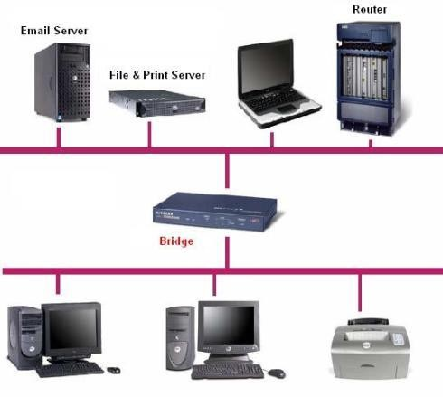

*Bridged network*

## ROUTERS

A router is a device that connects two LANs together to form an inter-network. A router is the basic building block of the Internet. Each router connects two or more networks together by providing an interface for an Ethernet network and ring network to which it is connected.

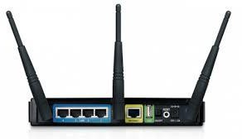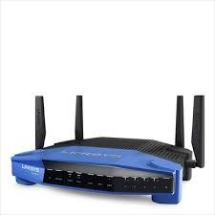

*Routers*

The router examines each packet of information to detection weather the packet must be translated form on one network to another network performing a function similar to a bridge. Unlike a ridge, a router can connect network that use

different technologies, addressing methods, media type, frame format and speeds. A router is a special purpose device designed to interconnect networks. Such that three networks can be connected using two routers. Routers maintain routing tables in their memories to store information about the physical connection on he network; the router examines each packet of data, checks the routing table and then forwards the packet if necessary. Every other router in the path (between any state destinations) performs a similar procedure. Note that a router does not maintain any state information about the packets; it simply moves them along the network. Routers are operated at layer 3(network) of OSI model.

## GATEWAYS

A gateway is node in a network that serves as an entrance to another network. In enterprises, the gateway node often acts as a proxy server and a firewall. The gateway is also associated with both a switch, which provides the actual path for the packet in and out of the gateway. It is also known as a computer system located on earth that switches data signals and voice signals between satellites and terrestrial networks. A gateway can operate at any layer of the OSI or TCP/IP reference model. The hub of a gateway, also called a protocol converter, is much more complex than that of a router or switch. Typically a gateway must convert from one protocol stack to another. E.g. a gateway may connect a TCP/IP network to an IPX. /SPX network. A Circuit Level Gateway function provided by Application level gateway products enables trusted users on private network to access Internet services with all security of a proxy server. An Application Level Gateway provide much stricter form of security that packet filters, but they are designed to regulate access only for a particular application.

## HUBS

Hubs are also called concentrators; expand one Ethernet connection into many. For example, a four-port hub connects up to four machines via UTP cables. The hub provides a star connection for the four ports. Many hubs contains a single BNC connectors as well to connect the hub to existing 10base2 network wiring, the hub can also be connected via one of its ports. One pot is desired to operate

in either straight through or crossover mode, selected by a switch on the hub. Hubs that can connect in this fashion are called stackable hubs. A hub is similar to a repeater, expect it broadcasts data received by any port to all other ports on the hub. Most hubs contain a small amount of intelligence as well. Examining received packets and checking them for integrity. If a bad packet arrives or the hub determines that a port is unreliable. It will shut down the line under the error condition is appears. The hub also acts like a repeater. Because of its slight delay when processing a packet, the numbers of hubs that may be connected in a series are limited.

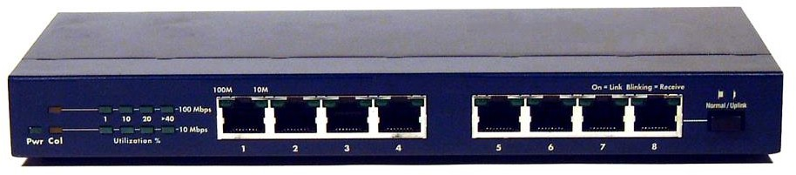

**There are three types of HUB passive hub, active hub and intelligent hub.** The Passive hubs do not process data signals with only purpose to combine the signal from several networks cables segments. All devices attached to the passive hub receive another packets that pass through the hub .Hub does not clear up or amplify the signals, on the contrary absorbs a small part of the signals that is why the distance between a hub and a computer should not be more than half of the permissible distance between two computers. Passive hubs have limited functionality so are inexpensive and easy to configure. It has four ports with four BNC (British Naval Connectors) female connectors to configure networks station or terminated with a 93 Ω BNC Terminator. The active hubs incorporate electronic components that amplify and cleanup the signals, that flaw between devices on the network. The process of cleaning up signal is called “signal regeneration”. The benefits of signals regeneration are:

* + - A network is more robust i.e. less sensitive errors.
    - Distance between devices can be increased.

Active hubs cost is considerable more than passive hub (active hub function impart as multi port repeaters). Intelligent hubs are enhanced active hubs the following functions add intelligence to a hub. Intelligent Hubs are units have form of integrated management capability.

**Hub Management** A hub supports networks network management protocols that enable the hub to send packets to central network console. Theses protocols enable network console to manage or control hub.

### Switching hubs

Switching hubs include circuitry that quickly routes signals between ports on the hub. Insured of repeating a packet to all ports on the hub, it repeats a packet only to the port that connects to the destination computer for the packet.

## SWITCHES

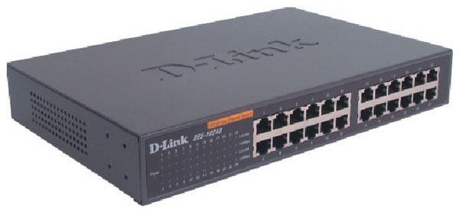It is similar to a bridge, with some important enhancement. First, as witch may have multiple ports, thus directing packets to several different segments further partitioning and isolating network traffic in as way similar to router. For example, if 8-port n way switch is there it can route packets from any input to any output.

Some or all of incoming packet is called store and forward, which stores the received packet before examining it to for error before retransmitting. Bad packets are not forwarded. A switch typically has auto-sensing 10/100 mbps ports and will just the speed of each port accordingly; furthermore, a managed switch supports SNMP for further control over network traffic. Switches operated at layer 2 (Data Link) of OSI model.

# EXPERIMENT-3

### Aim: To study the working of Basic Networking Commands; hostname, ipconfig, ping, host, telnet, ftp, net, arp, winipcg, nslookup, netstat

* 1. **Learning objective:**

At the end of the session you will be able to be familiar with working of different networking commands like: hostname, ifconfig, ping, host, telnet, ftp, net, arp, Winipcg, nslookup etc.

**Networking Commands:** The following commands are essentially used for network management.

* 1. **hostname**

This command is used for finding host/domain name and IP address.

**Example:**

**hostname** *with no options displays the machines host name* **hostname –d** *displays the domain name the machine belongs to* **hostname –f** *displays the fully qualified host and domain name*

**hostname –i** *displays the IP address for the current machine*

* 1. **ifconfig**

This command will display the assigned IP address of ETHERNET adapter.

Ubuntu : ifconfig | grep inet

Windows : ipconfig

### ping

This command is used for checking the network connectivity.

***Ping*** verifies IP-level connectivity to another TCP/IP device by sending Internet Control Message Protocol (ICMP) Echo Request messages. If received, the corresponding Echo Reply messages are displayed, along with round-trip times. Otherwise, a timed-out request or an ICMP unreachable message is displayed.

(i.e. You can “ping” an IP address to see if a machine is alive. If there is no response, you know something is wrong)

### host

This command is used for mapping name to IP addresses?

Example: host [www.google.com](http://www.google.com/) [www.google.com](http://www.google.com/) has address 74.125.200.147 [www.google.com](http://www.google.com/) has address 74.125.200.106

[www.google.com](http://www.google.com/) has address 74.125.200.103 [www.google.com](http://www.google.com/) has address 74.125.200.104 [www.google.com](http://www.google.com/) has address 74.125.200.105 [www.google.com](http://www.google.com/) has address 74.125.200.99

[www.google.com](http://www.google.com/) has IPv6 address 2404:6800:4003:c00:: 69

### telnet

This command is used for connecting to a host on a particular port.

Example: telnet osou.ac.in 80

***telnet*** command is also used to make a connection to a remote machine and execute programs as if one were physically present.

telnet (data are travelled without encryption; not secured)

### ftp

This command allows you to send and receive files between two computers.

### net

***net*** command is used for checking/starting/stopping networking services, users, messaging, configuration and so on... ?

### arp

This command is used for displaying or manipulating the ARP (Address Resolution Protocol) information on a network device or computer.

**Explanation:** The ARP protocol maps Layer 3 IP addresses to Layer 2 MAC addresses. If a packet must move across networks, the Layer 2 MAC address changes with each hop across a router, but the Layer 3 address never changes. ARP cache stores ARP address mappings. If the entry was learned dynamically, it will eventually be deleted from cache. If the entry was manually inserted in ARP cache, it is a static entry and will remain until the computer is turned off or the ARP cache is manually flushed.

On Windows, ***arp*** displays and modifies entries in the Address Resolution Protocol (ARP) cache, which contains one or more tables that are used to store IP addresses and their resolved Ethernet or Token Ring physical addresses. There is a separate table for each Ethernet or Token Ring network adapter installed on your computer. Used without parameters, ***arp*** displays help.

### Winipcg

This command is used to know the IP configuration of the PC in a graphical form. It shows the following in the windows command prompt.

* + - IP Address
    - Subnet Mask
    - Type of H/W used for communication & it’s address

### nslookup

This command displays information from Domain Name System (DNS) name servers.

NOTE: If you write the command as above it shows as default your pc's server name firstly.

### netstat

This command is used for finding connection to and from the host?

### Example:

**netstat nap| grep port** *will display process id of application which is using that port*

**netstat a or netstat –all** *will display all connections including TCP and UDP*

**netstat tcp or netstat –t** *will display only TCP connection*

**netstat udp or netstat –u** *will display only UDP connection*

**netstat g** *will display all multicast network subscribed by this host.*

# EXPERIMENT-4

**AIM : Installation of Cisco Packet Tracer, and Interface Explanation**

* 1. **Learning objective: At the end of the session, students will be able to install the Cisco Packet Tracer and understand the interface.**

**Packet Tracer Download and Installation Instructions**

Follow these instructions to download and install Packet Tracer.

# Step 1: Download the Packet Tracer installation file.

1. Navigate to the **Resource Hub** here: https://skillsforall.com/resources/lab-downloads
2. Packet Tracer is available for Windows, Linux, and macOS operating systems. Click the download link that is appropriate for your computer.

**Note**: Packet Tracer is not available for mobile devices such as smartphones and tablets.

1. Choose a location to save the installation file.
2. For the next step, choose your operating system to continue. Ignore sub steps that do not apply to your operating system.

# Step 2: Install the Packet Tracer application.

## Windows

1. Navigate to the location where you saved the Packet Tracer installation file.
2. Double click the Packet Tracer installation file.
3. The **Setup** dialog opens to the **License Agreement**. Read through the agreement, click **I accept the agreement**, and then click **Next**.
4. In the **Select Destination Location** window, choose a location or accept the default location, and then click **Next**.
5. In the **Select Start Menu Folder** window, you can choose a different installation folder, if you prefer, or accept the default location, and then click **Next**.
6. In the **Select Additional Tasks** window, you can choose your **Additional shortcuts**, and then click **Next**.
7. In the **Ready to Install** window, review your installation settings. If you need to change anything, click **Back** to navigate back to a setting you wish to modify. When ready, click **Install** to begin the installation process.

## Ubuntu (Linux)

Packet Tracer can be installed via CLI using user credentials with elevated privileges.

1. Open a terminal and navigate to the location where you saved the Packet Tracer installation file.
2. Enter the following command to install Packet Tracer and provide the user password when prompted. User@Ubuntu:~/Downloads$ **sudo apt-get install ./CiscoPacketTracer_xxx_Ubuntu_64bit.deb** where xxx is Packet Tracer version.
3. The **Setup** dialog opens to the **License Agreement**. Read through the agreement. Use the tab key to

highlight **<OK>** and press **Enter** to continue.

**Note:** The mouse does not work while installing Packed Tracer using CLI.

1. Use the tab key to select **<Yes>** and press **Enter** to accept the License Agreement.

## Packet Tracer Download and Installation Instructions

Now you should be able to open Packet Tracer via the Application menu or the command **packettracer** in the terminal.

## macOS

1. Navigate to the location where you saved the Packet Tracer disk image (.dmg) file.
2. Double click the Packet Tracer disk image file.
3. Select **Open.**
4. The **Setup** dialog appears. Click **Continue** to view and accept the **License Agreement**. Read through the agreement, click **I accept the agreement**, and then click **Continue**.
5. In the **Ready to Install** window, select **Install**. You may be prompted to enter your system account password or security PIN for Packet Tracer to write system configurations.
6. When installation is finished, if the **Create Maintenance Tool** window opens, click **Continue**.
7. Click **Done** to complete the installation process.
8. Open **Finder** and go the **Applications** folder. Open the Cisco Packet Tracer folder and launch the Cisco Packet Tracer application.

# Step 3: Launch the Packet Tracer application.

1. When installation finishes, the Launch Cisco Packet Tracer checkbox will be checked. Click Finish to launch Packet Tracer.
2. Alternatively, locate Packet Tracer in its installation location and double click the application.
3. The first time Packet Tracer opens, it will ask **Would you like to run multi-user when the application starts?** You can click **No** to this question for now.
4. You may get a security message, such as **Windows Security Alert**. Some advanced features, such as multi-user Packet Tracer, require network access. However, if you prefer, you can turn off private and public network access.
5. The **Cisco Packet Tracer Login** window opens. Notice the toggle that allows you to Keep me logged in (for 3 months). If you would prefer not to log in each time Packet Tracer opens, click the toggle if you are not on a public or shared computer.
6. Click **Skills For All**.
7. If your web session with Skills For All is recent, a web browser tab will open with the message: **You have successfully logged in to Cisco Packet Tracer. You may close this tab.** Close the tab and return to Packet Tracer.
8. If your session has expired, a web browser tab will open for you to log back into Skills For All. Enter your credentials to login. The web browser tab will now display the message: **You have successfully logged in to Cisco Packet Tracer. You may close this tab.**
9. If necessary, return to Packet Tracer. You are now ready to explore its features.

# EXPERIMENT-5

### Aim: Design and Simulation of star and bus topology on Cisco Packet Tracer

**Learning objective:**

**At the end of the session, you will be able to create and simulate the star and bus topology on Cisco Packet Tracer**

**Connect 2 PCs using Packet Tracer just to understand the connection and run the ipconfig command to verify the connection.**

**Steps**

**Place 2 PCs and connect with cross cable .**

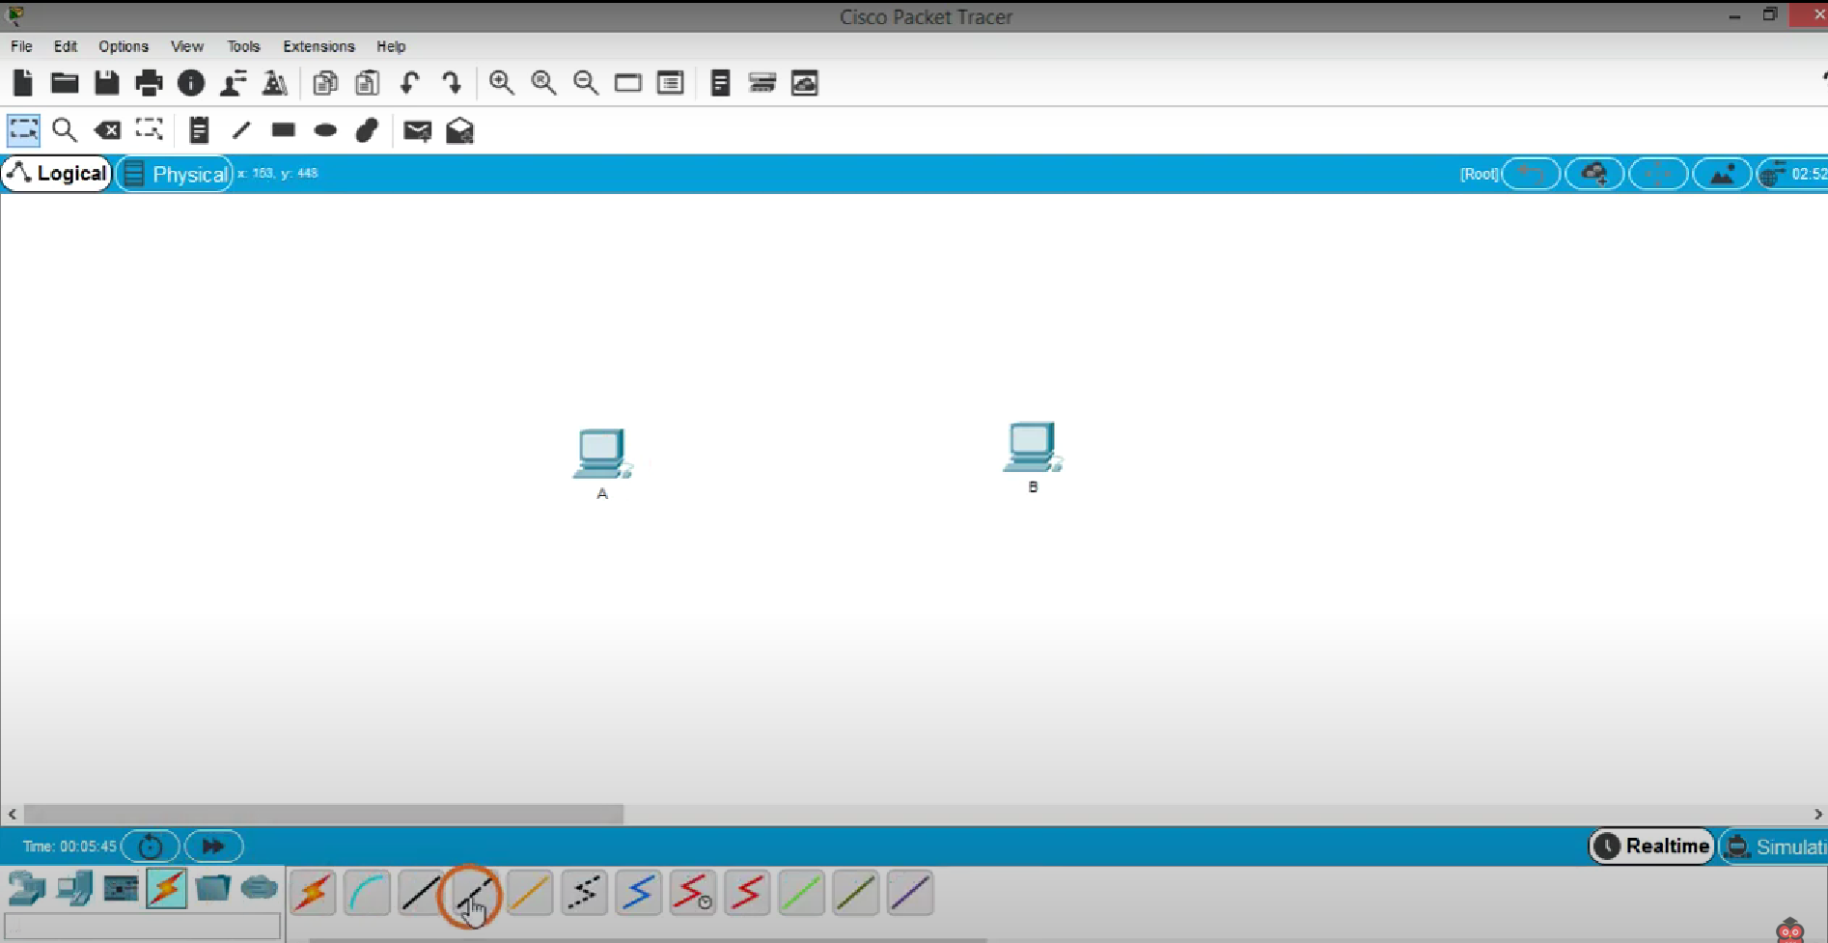

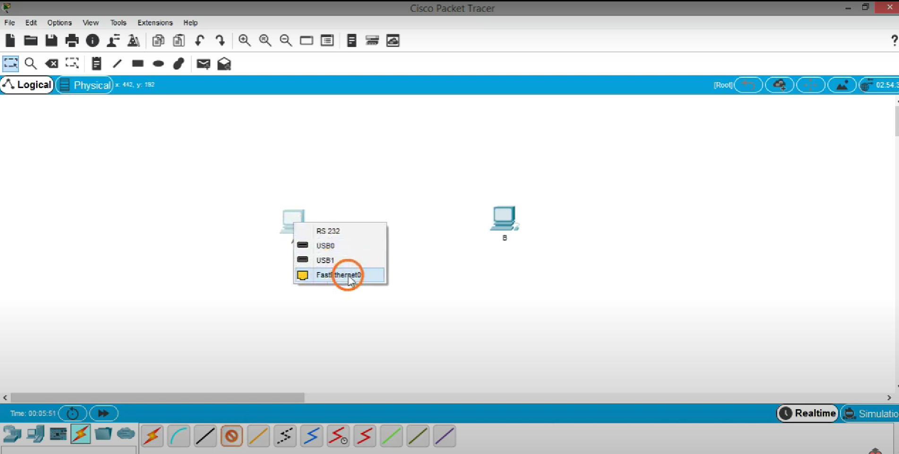

**-Similarly for second PC**

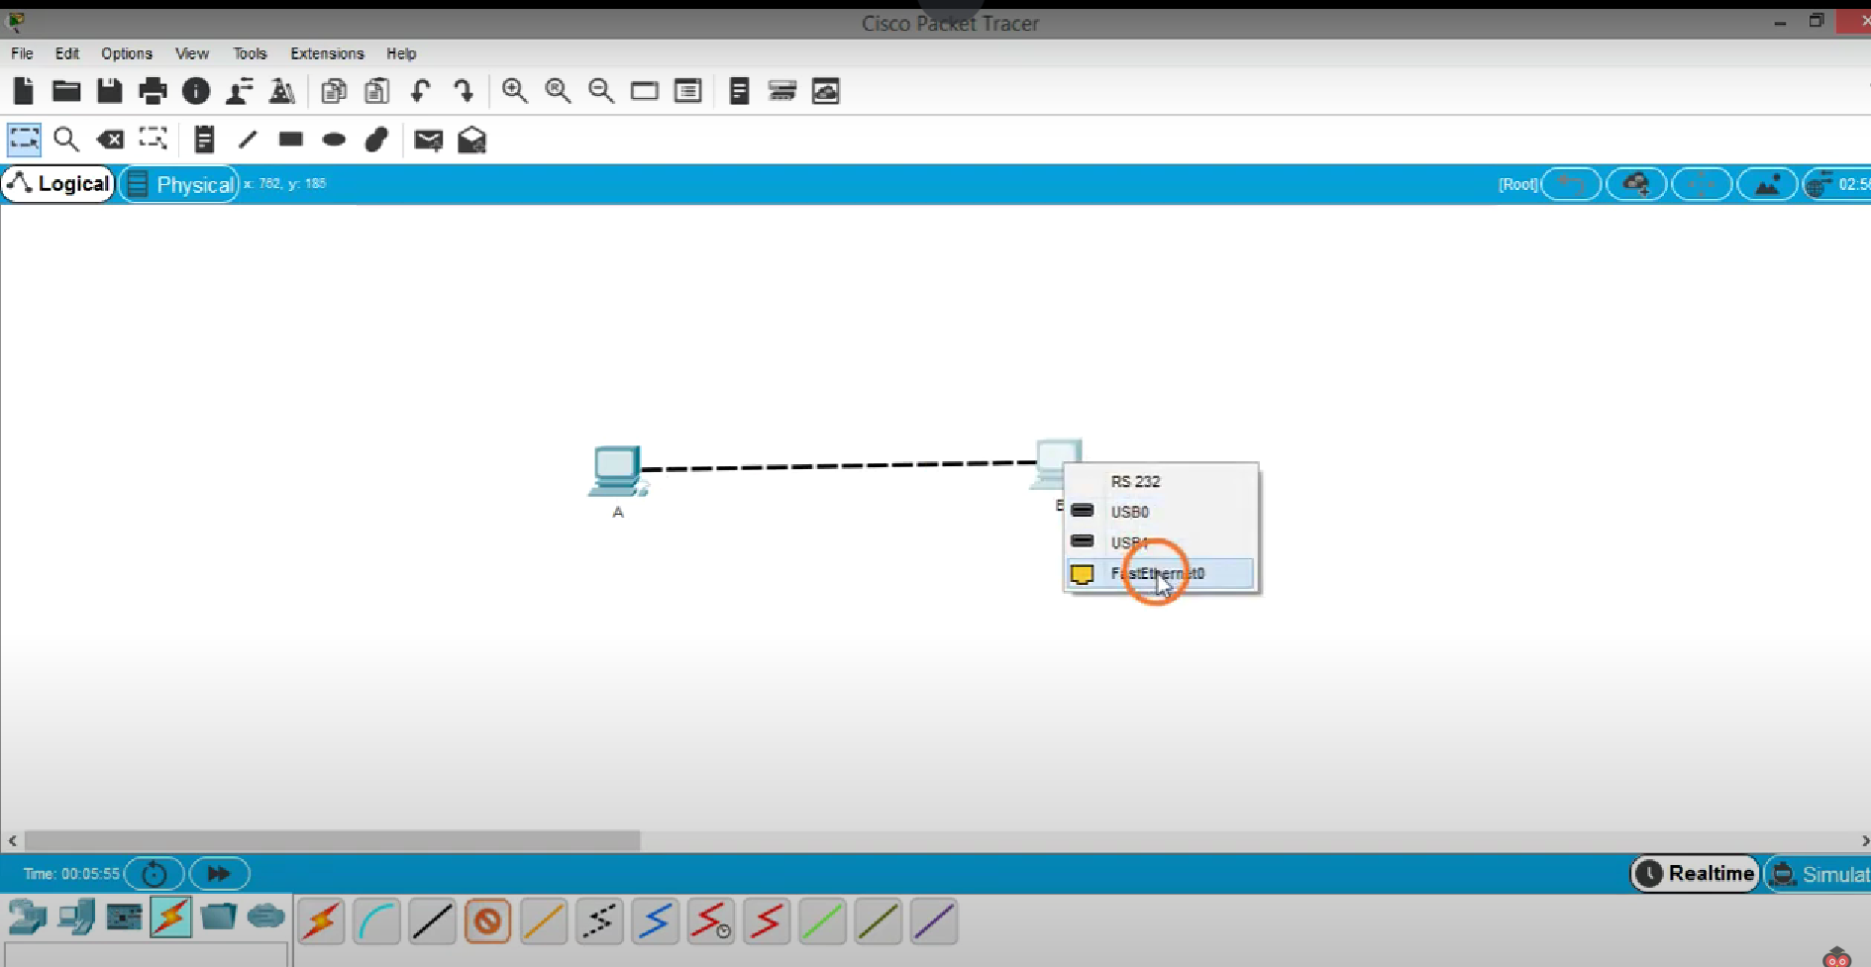

* **hen assign the IP address to both PC for this click on PCs and go to Desktop**

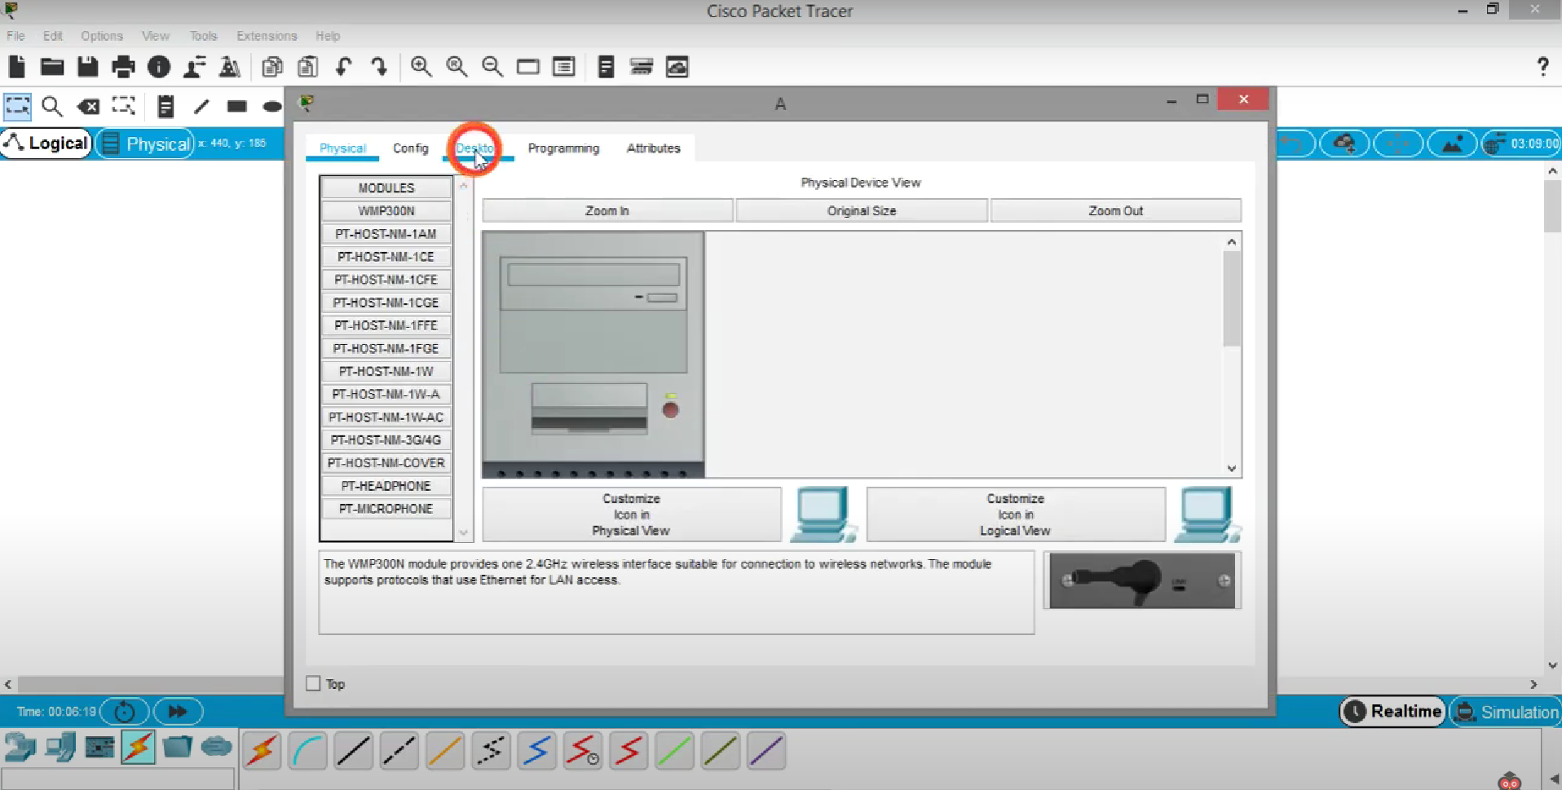

**-Click on IP configuration**

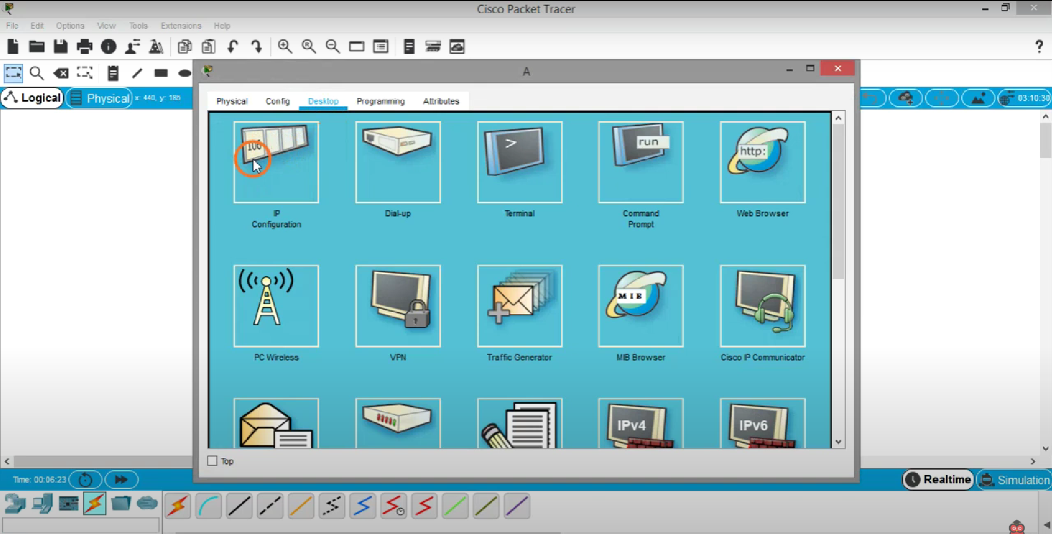

**-Give a private IP like 192.168.1.1 similarly do to 2nd PC**

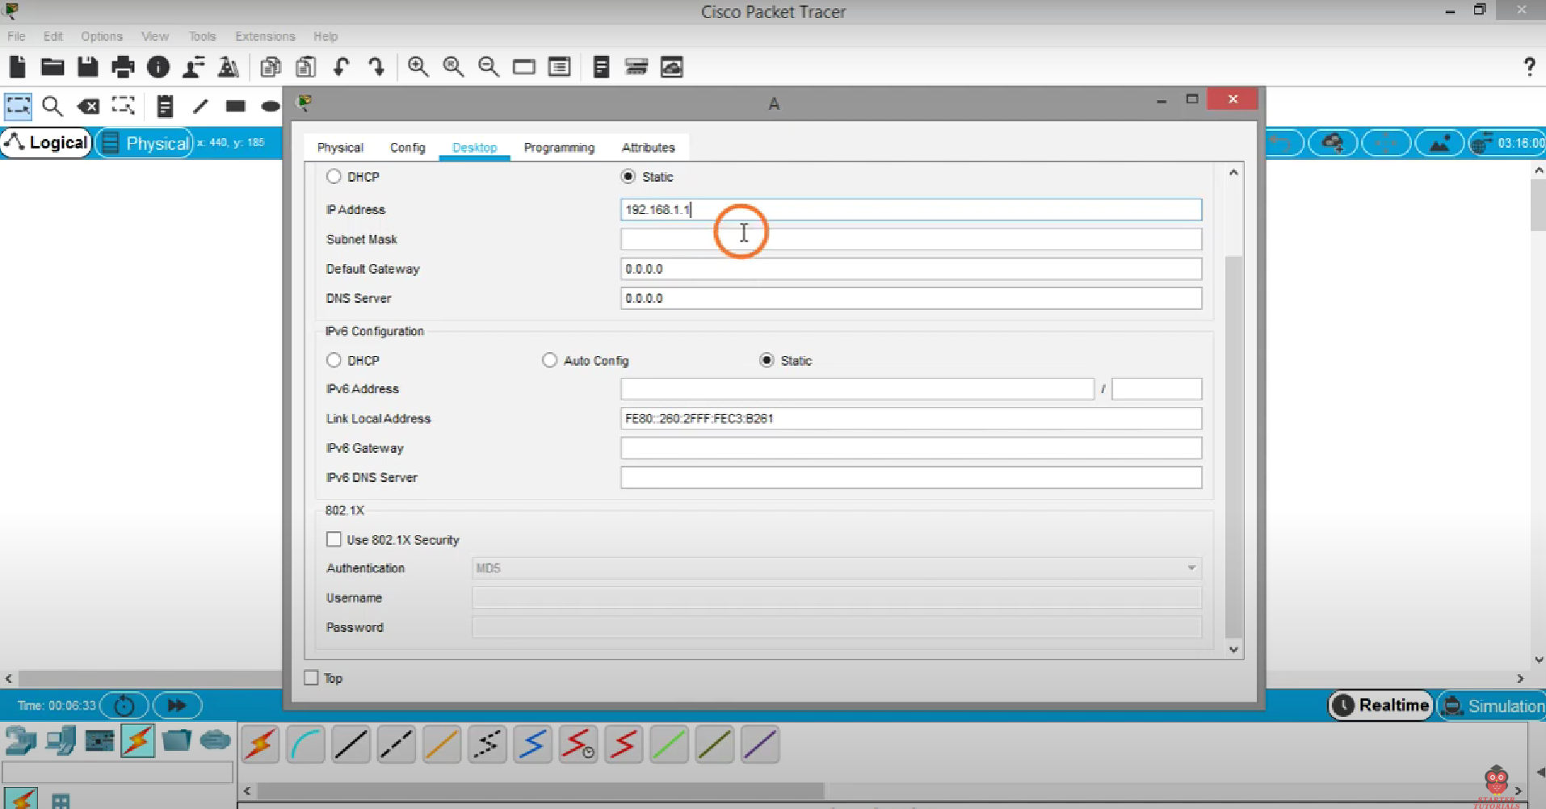

**Now click on simulation button**

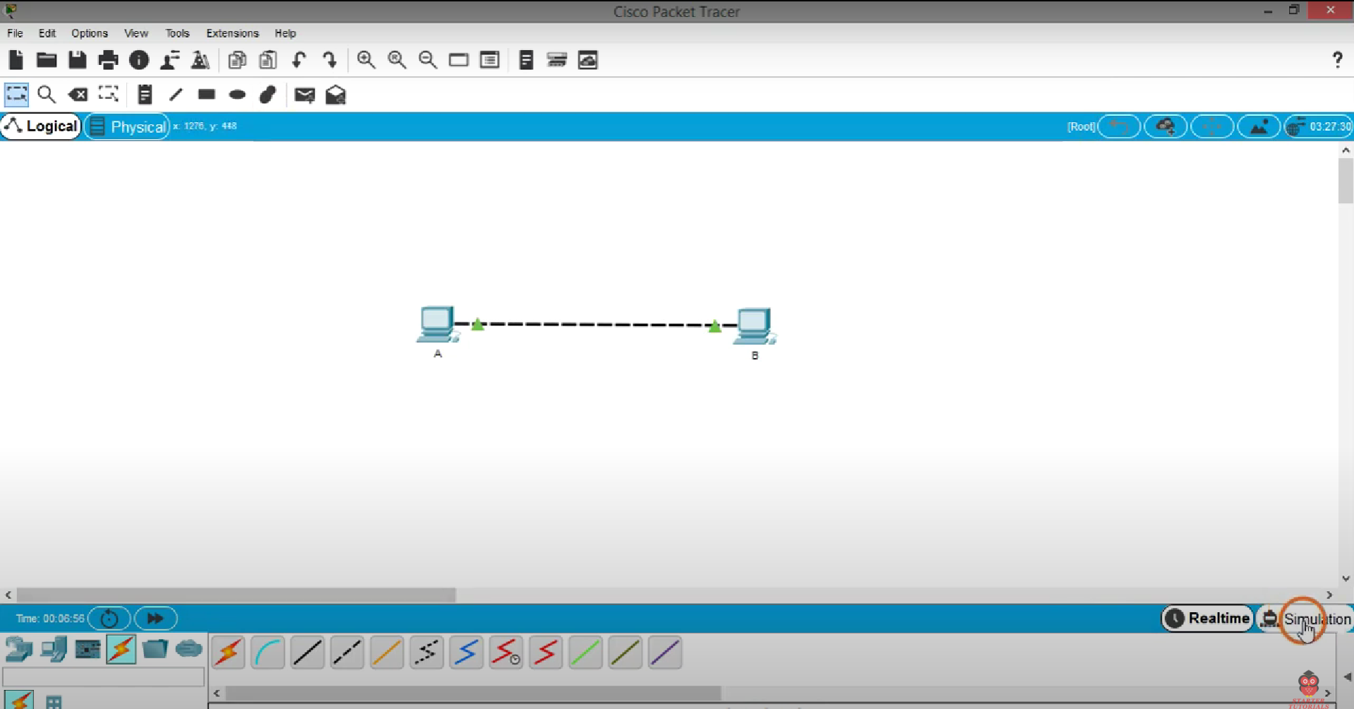

**Then click on edit filter check ICMP**

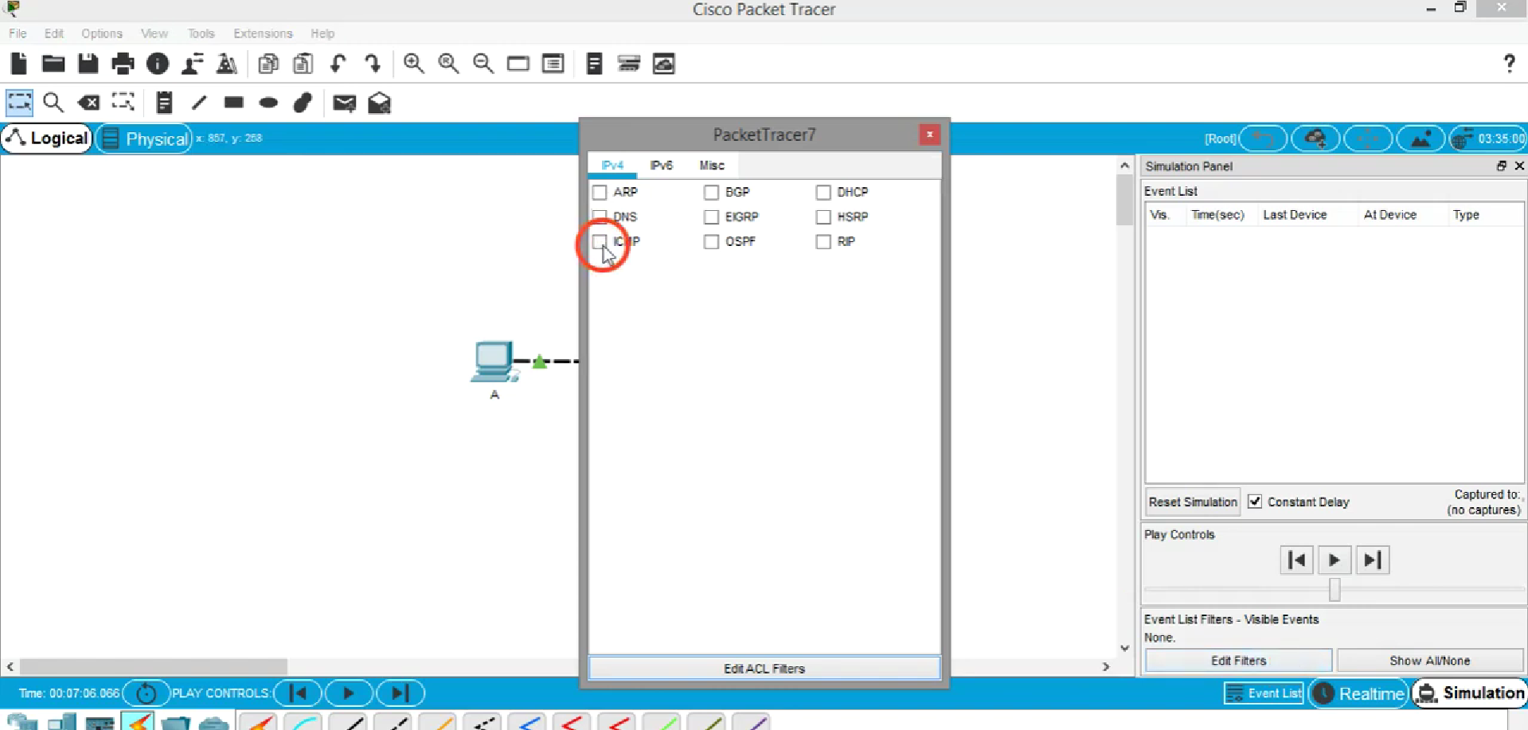

**Add a pdu to PC A**

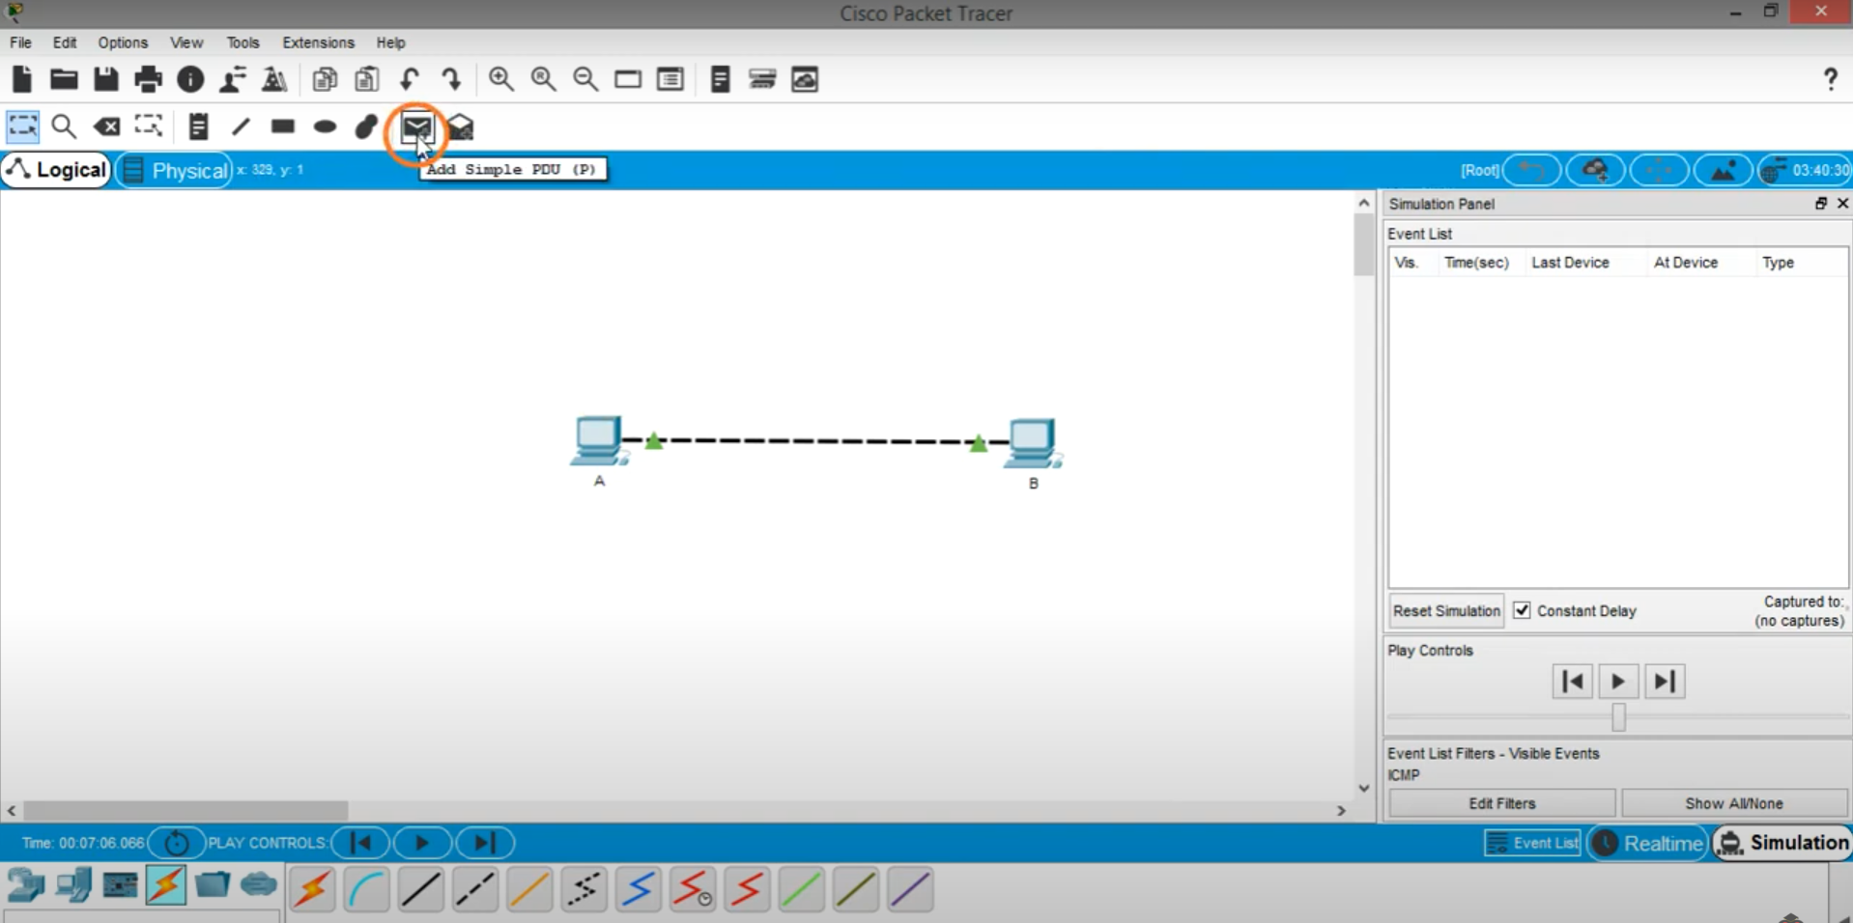

**-Then make source PC A and destination PC B**

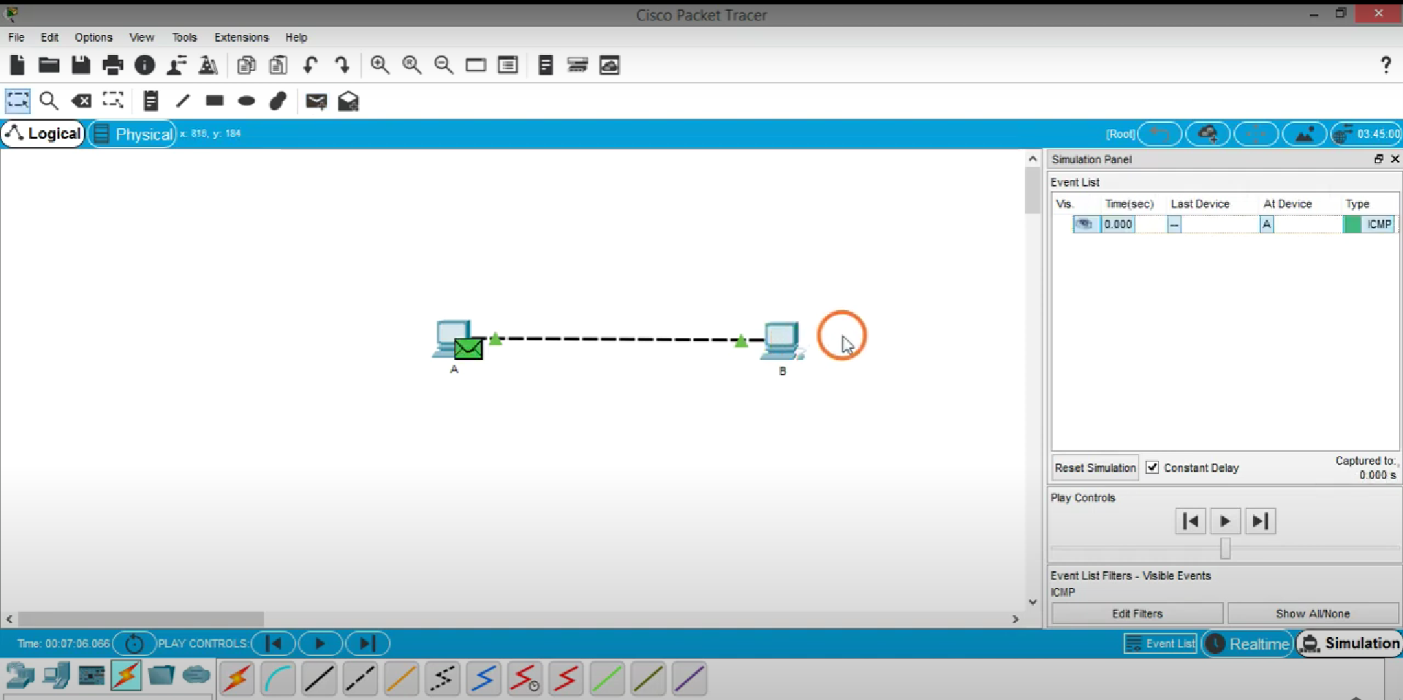

**Now click on the forward button for transmission**

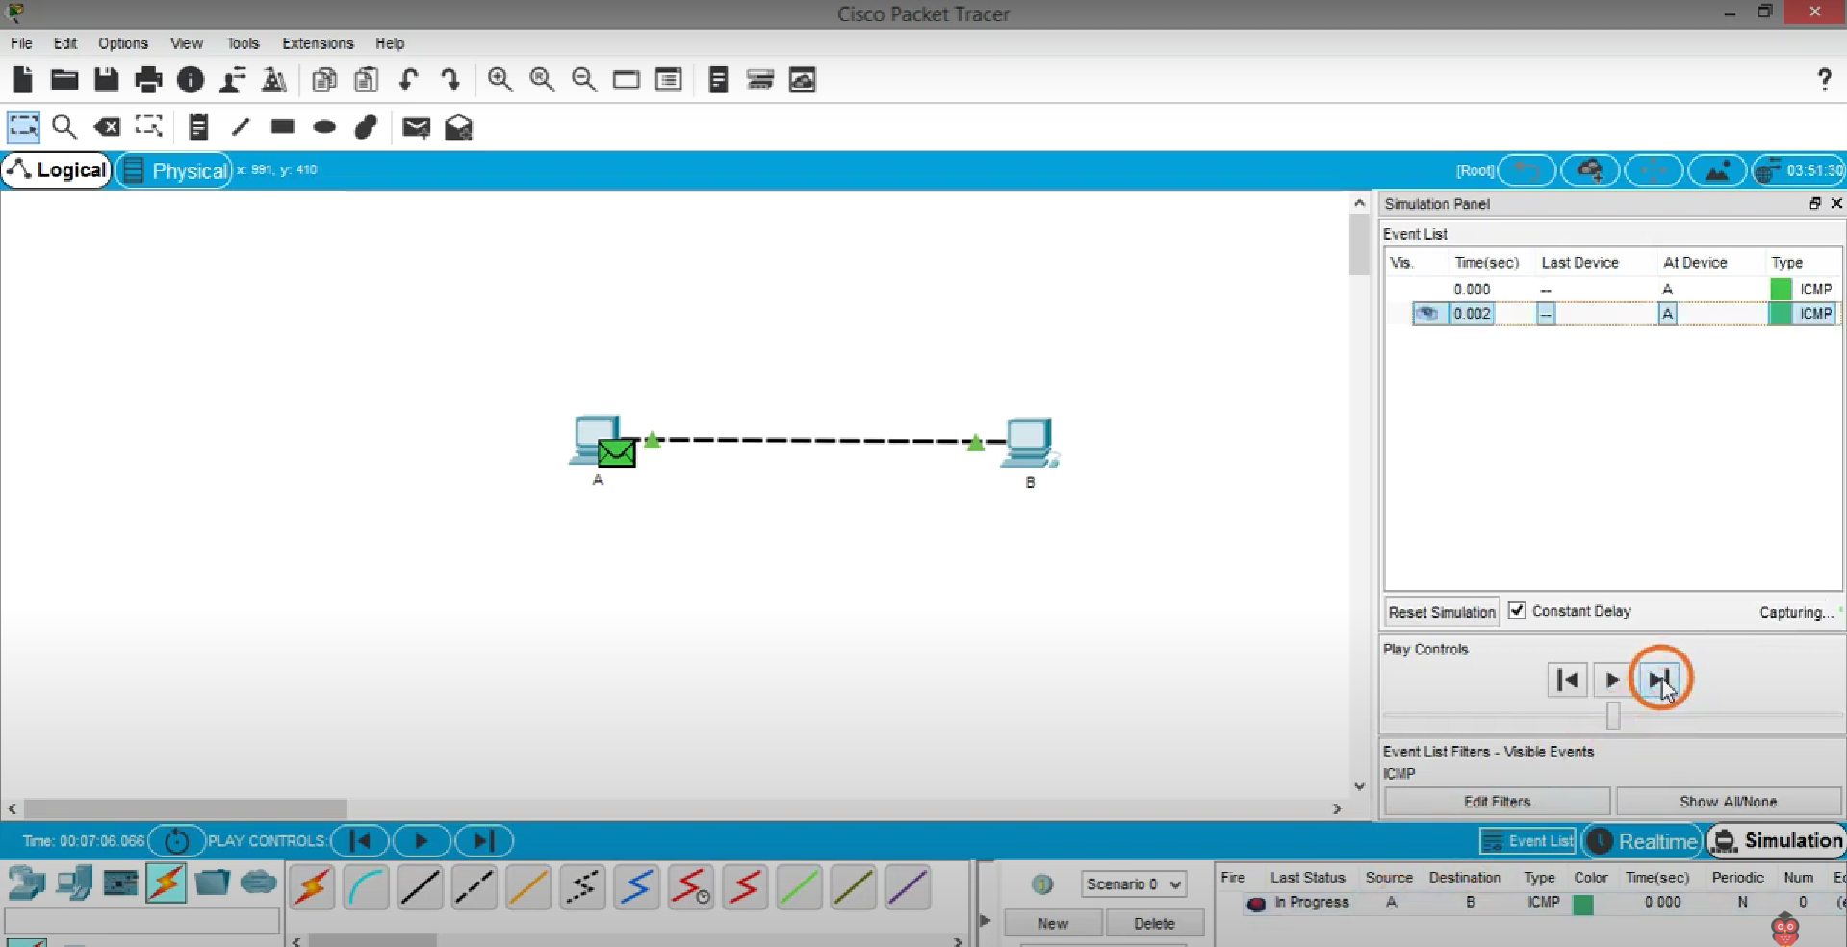

**Ipconfig for given connection.**

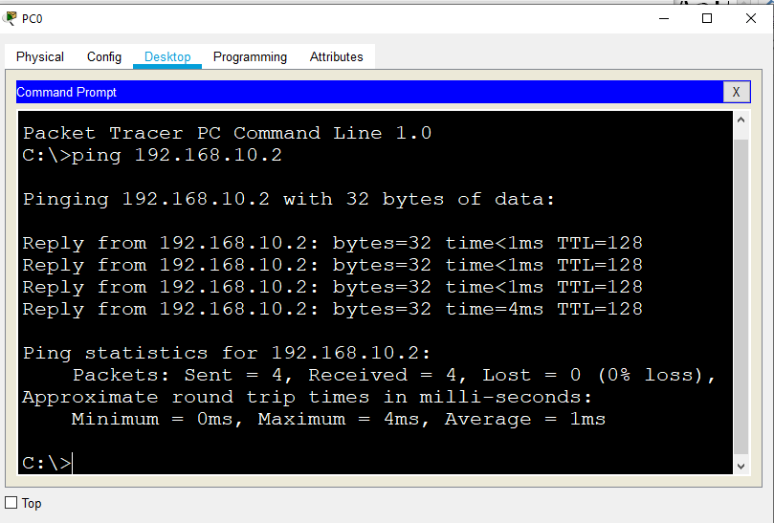

**Steps 1**

**Just place the 4 PC AND RENAME**

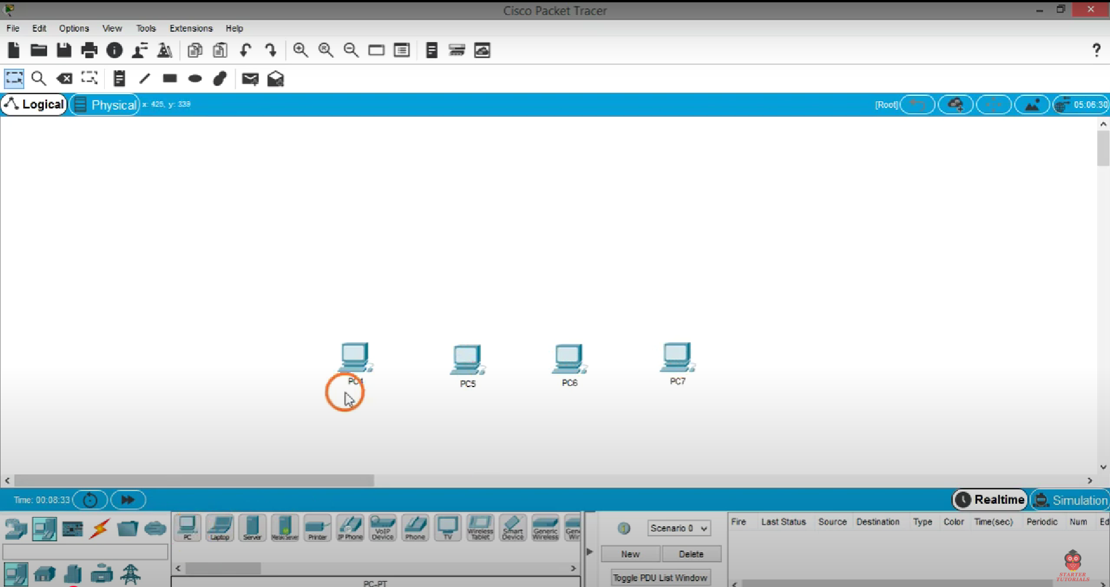

**-let place a hub CLICK network devices then click PT hub**

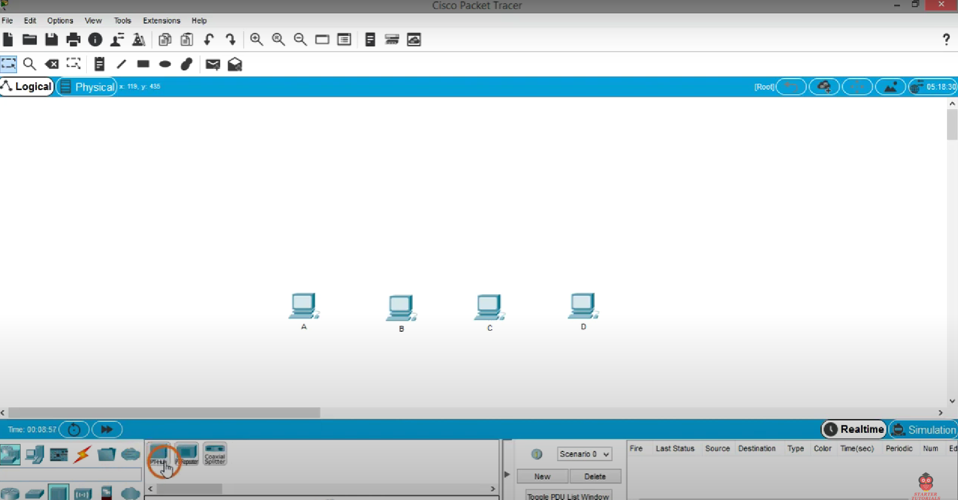

**Then place the hub**

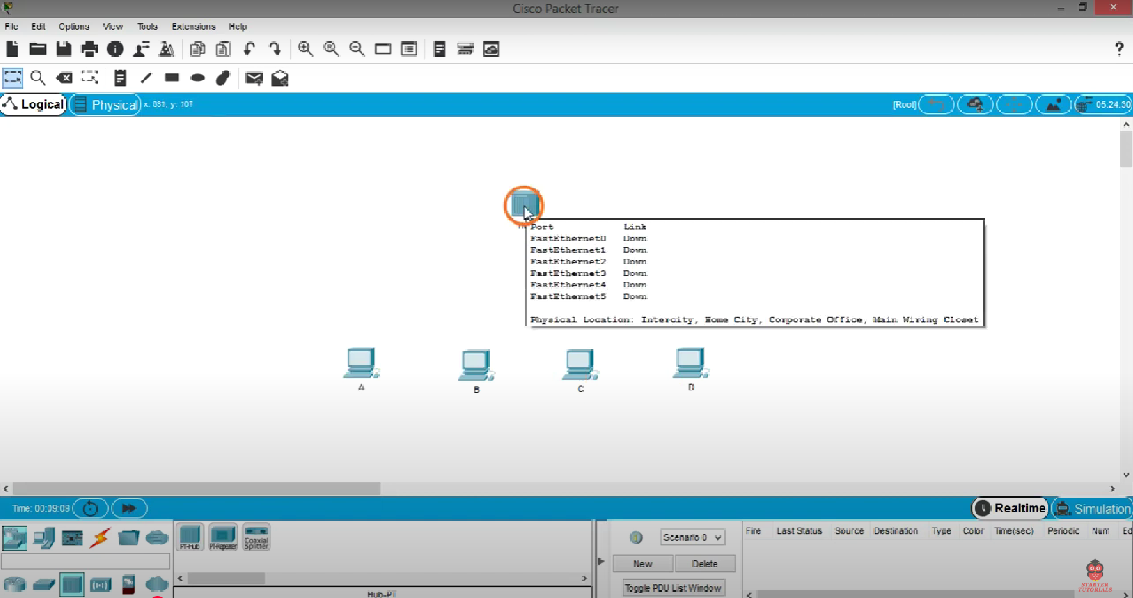

**Then connect all 4 pc to HUB with straight cable (not similar device)**

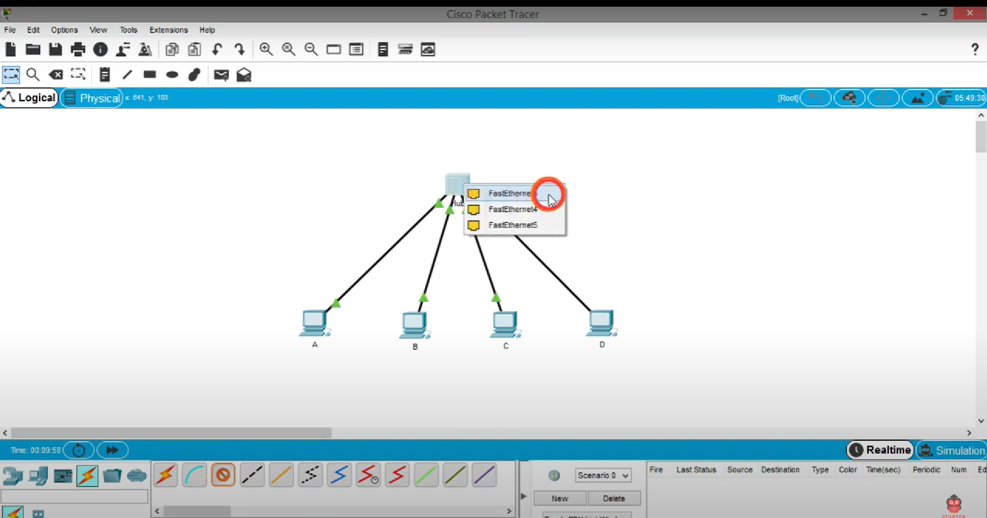

**Assign IP address to all Pcs and ping any PC to check the connectivity**

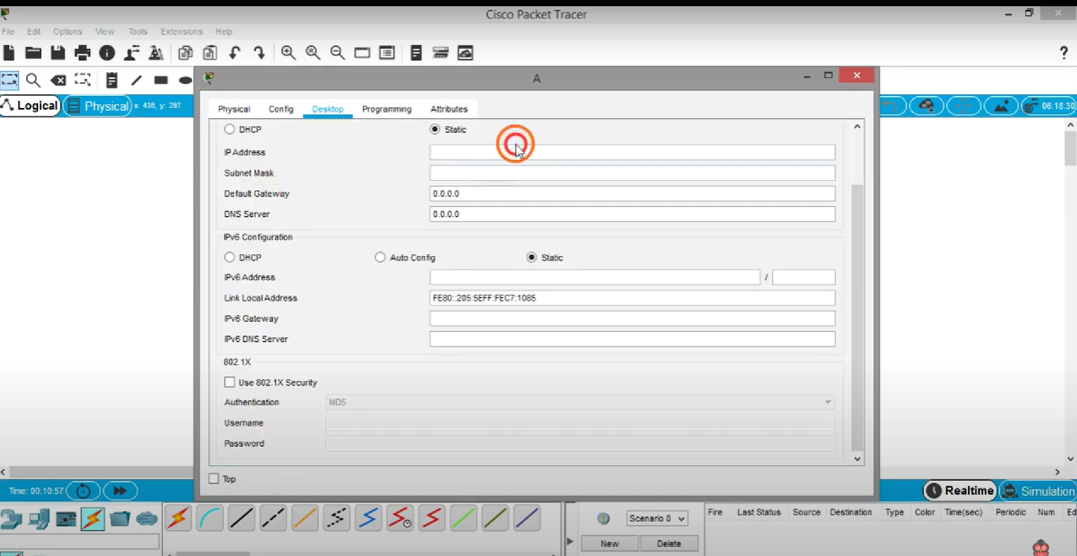

**Add a PDU to system A and destination System D**

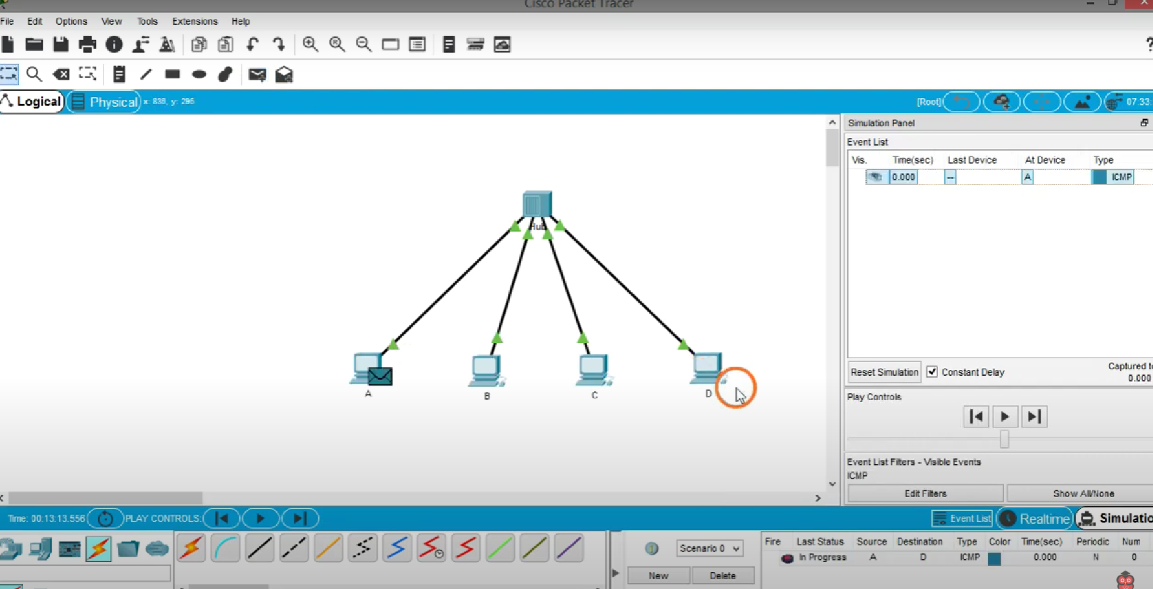

**Do a simulation and observe the behavior of the hub**

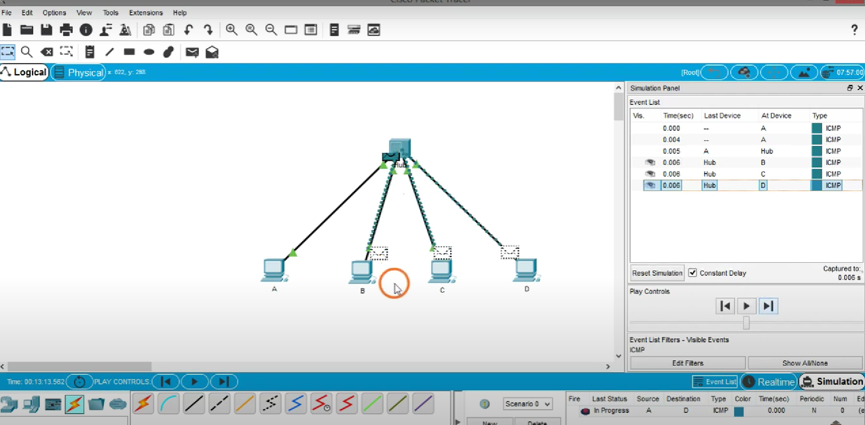

**Hub broadcast the PDU to all pc o**

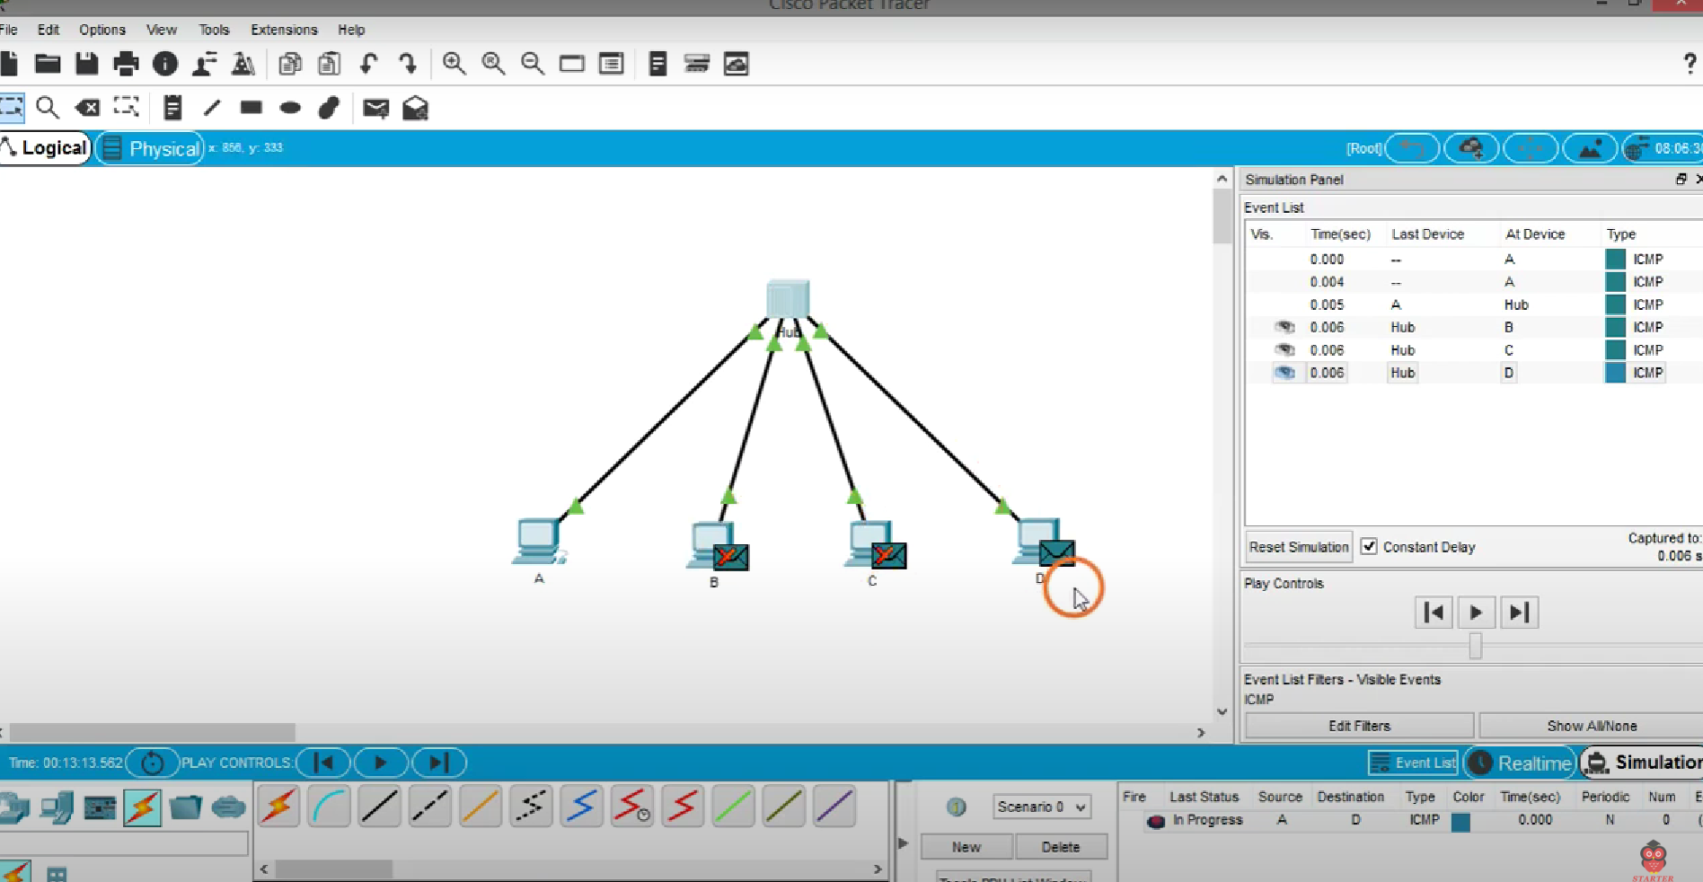

**Make the same topology with the switch and observe the behavior.**

**Creation of BUS topology**

**Step 1: Put 6 PC on design panel**

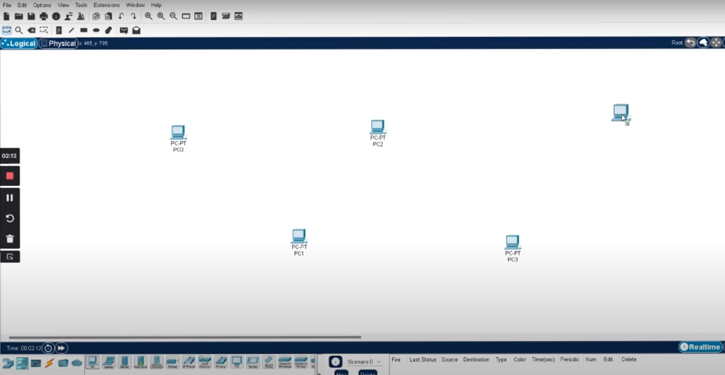



**Step 2: Put Hub in front of PCs.**

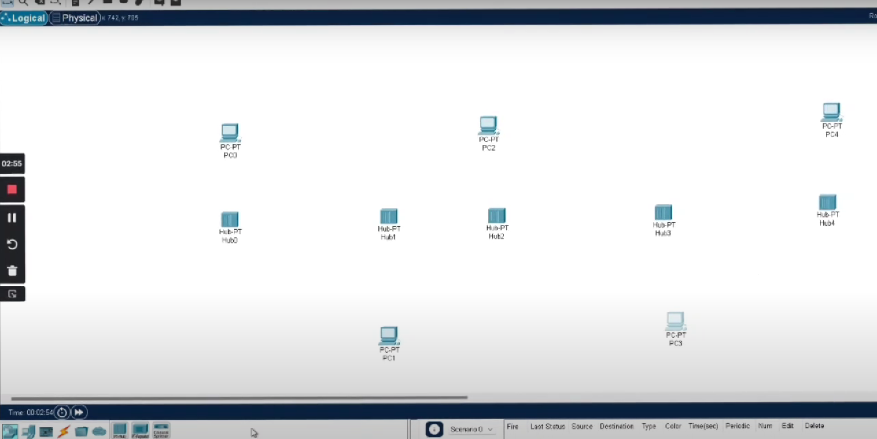



**Step 3; connect the similar devices with a cross cable and dissimilar device with straight cable**

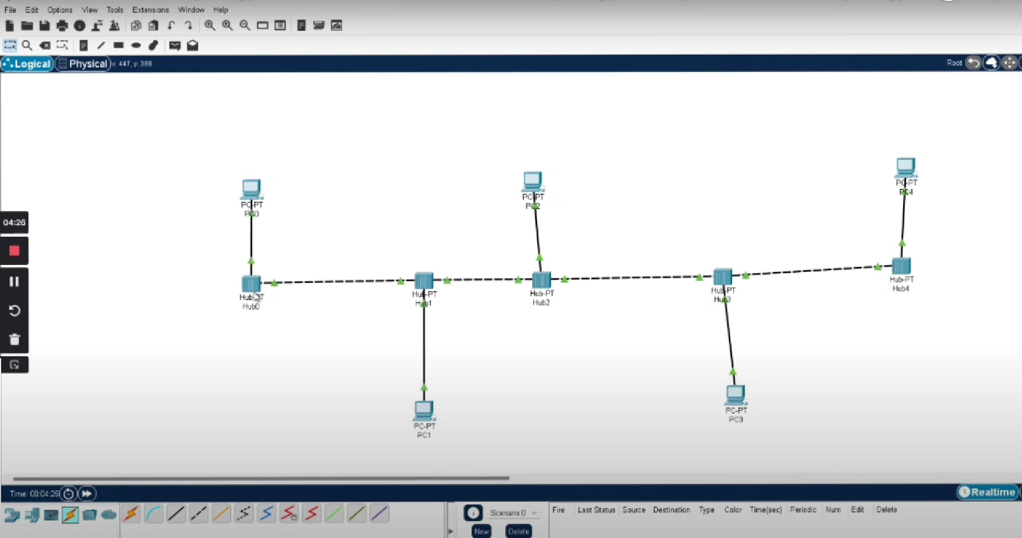



**Step 4 : Assign IP to each PC e.g. 192.168.1.1 to 192.168.1.5**

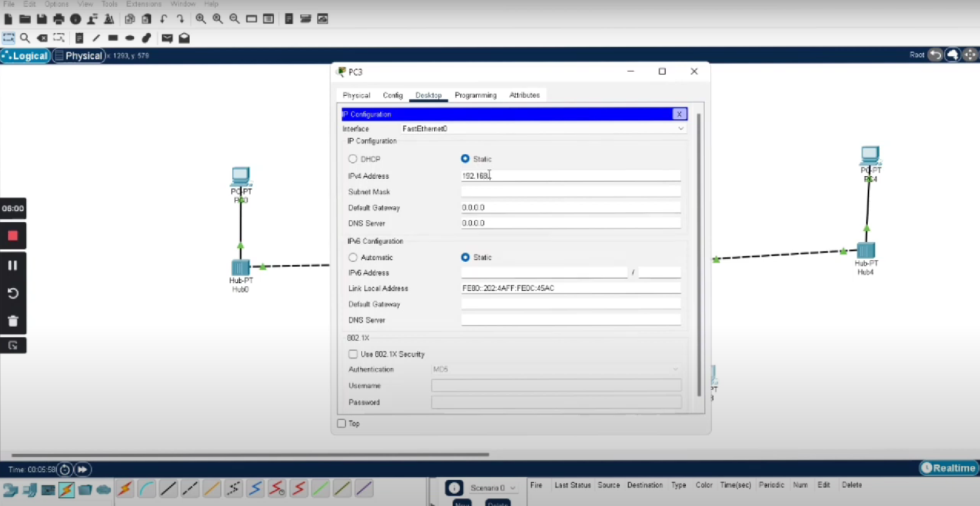

**Step 5 : Test connection by ping any of the PC ( e.g. go to the command prompt in packet tracer and ping 192.168.1.4**

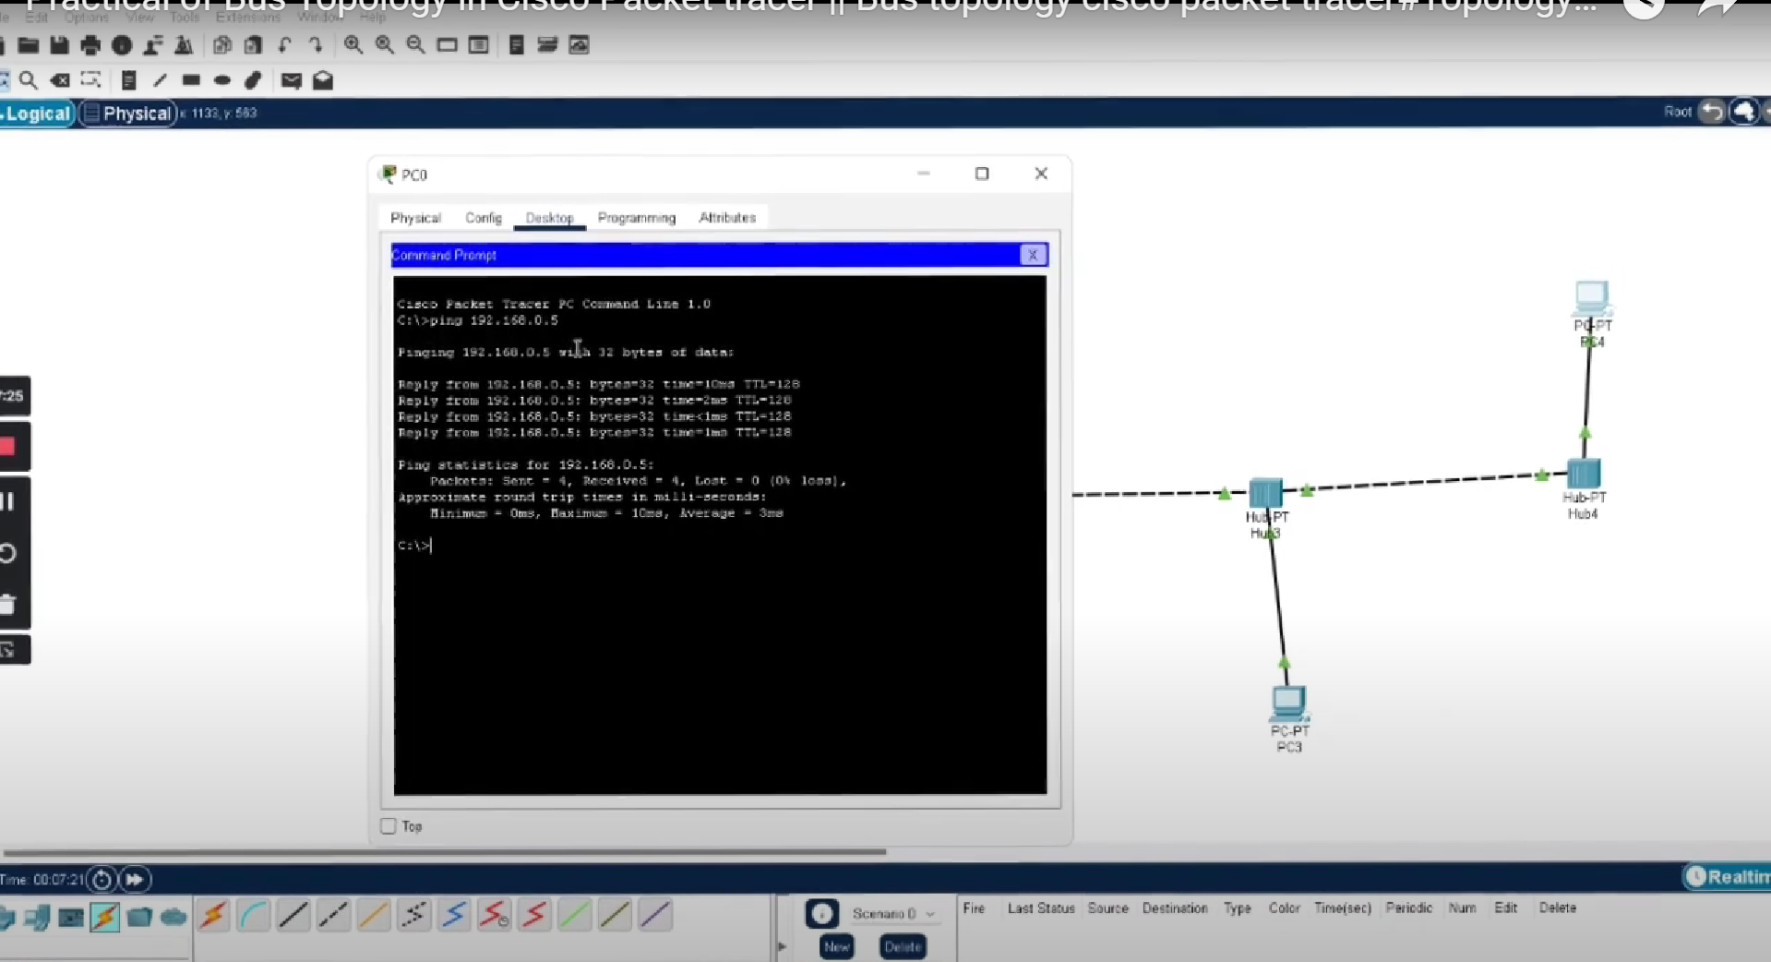

**Step 6: for ease of observation put IP address of the PC aside with it using the note option**

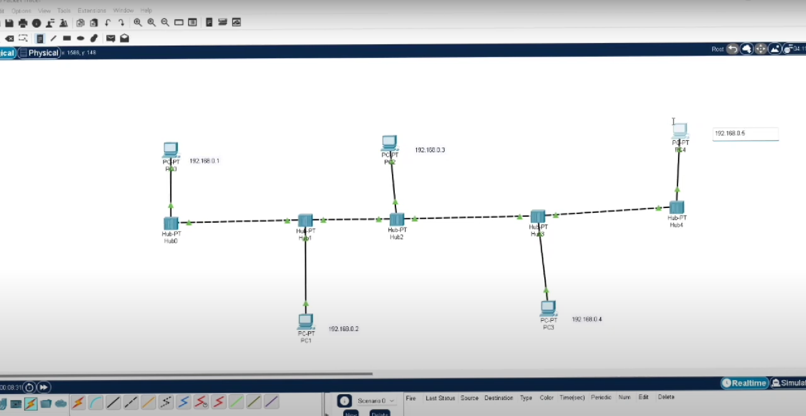



**Step7: take PDU and select source and destination**

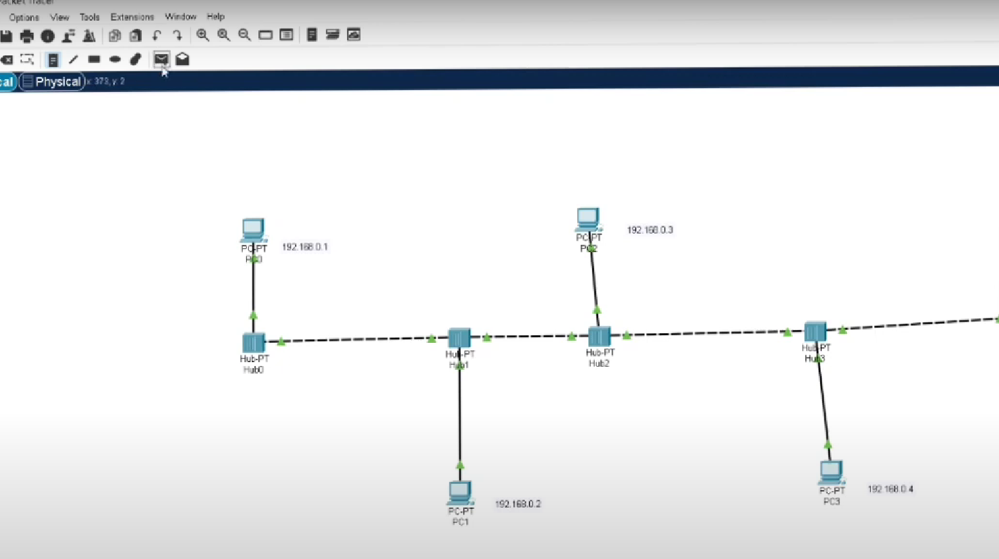



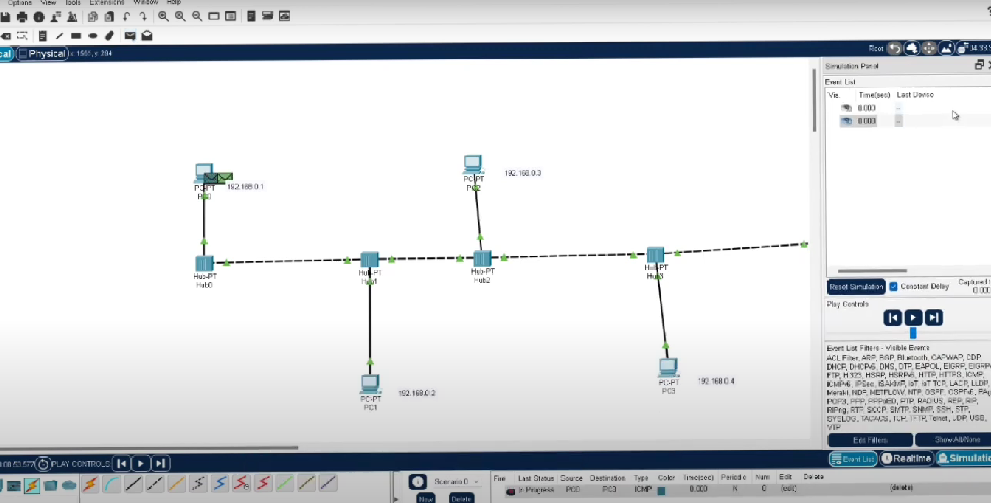

**Step: 8 Observe the stepwise simulation and behavior of the topology**

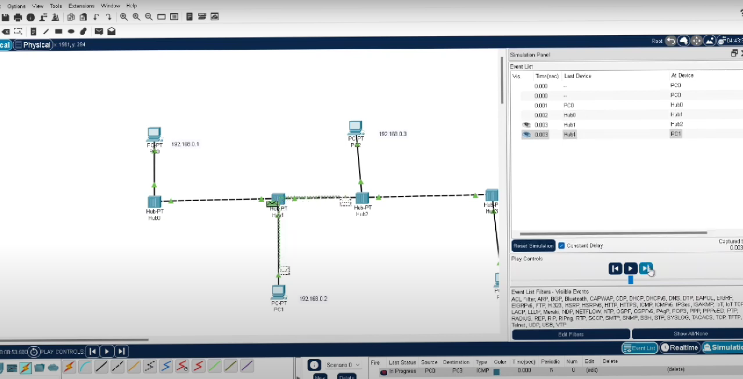



# EXPERIMENT-6

### Aim: Design and Simulation of mesh and Ring topology on Cisco Packet Tracer

**Learning objective:**

**At the end of the session, you will be able to create and simulate the Mesh and Ring topology on Cisco Packet Tracer**

**Designing of Mesh topology**

**Step1: Put 5 PCs on design panel**

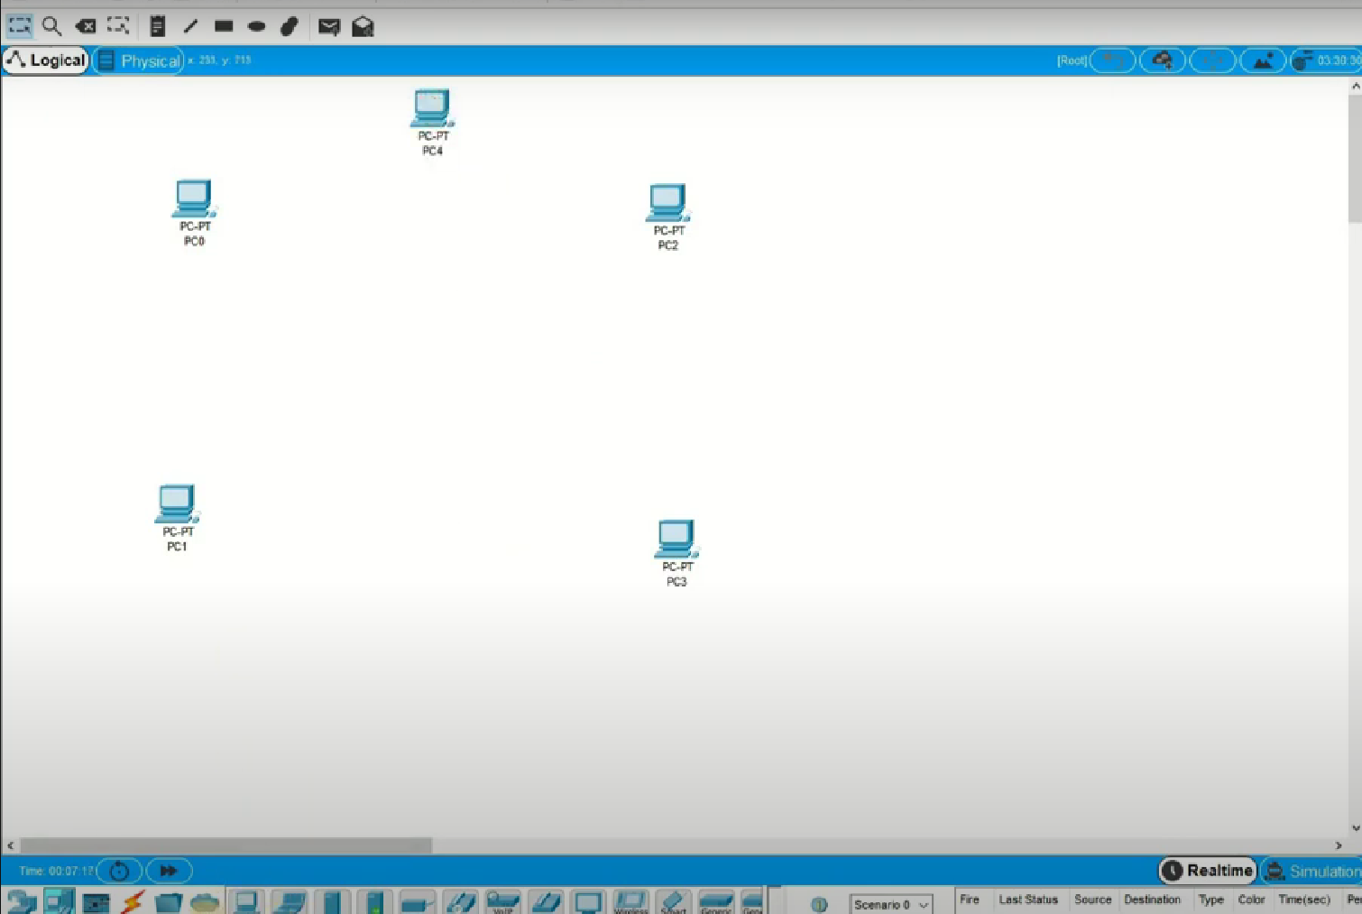

**Step 2: Put 5 switches for every PCs as shown in the screenshot.**

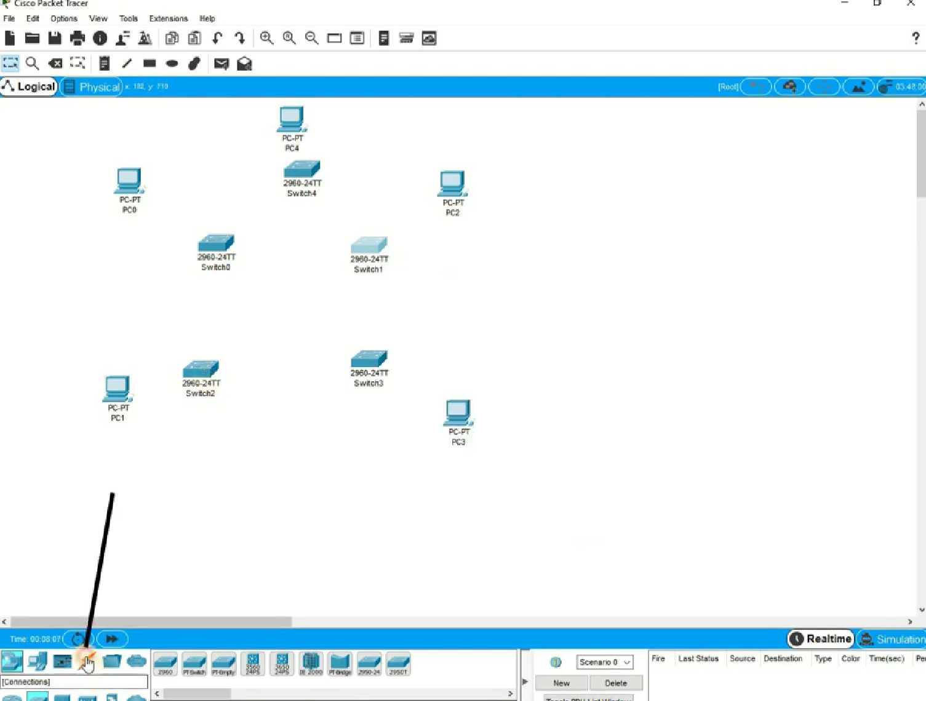

**Step 3: Connect all Switches in mesh form as shown in the screenshot.**

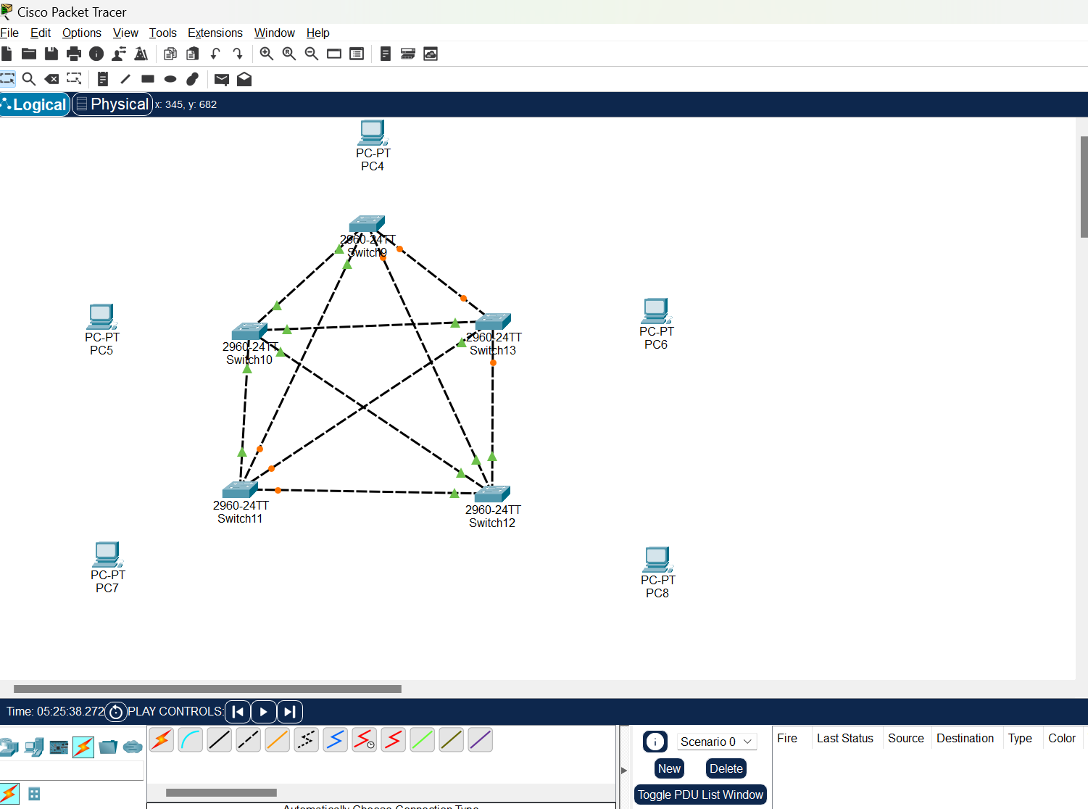

**Step 4: Connect all switches with their respective PCs as shown in the screenshot.**

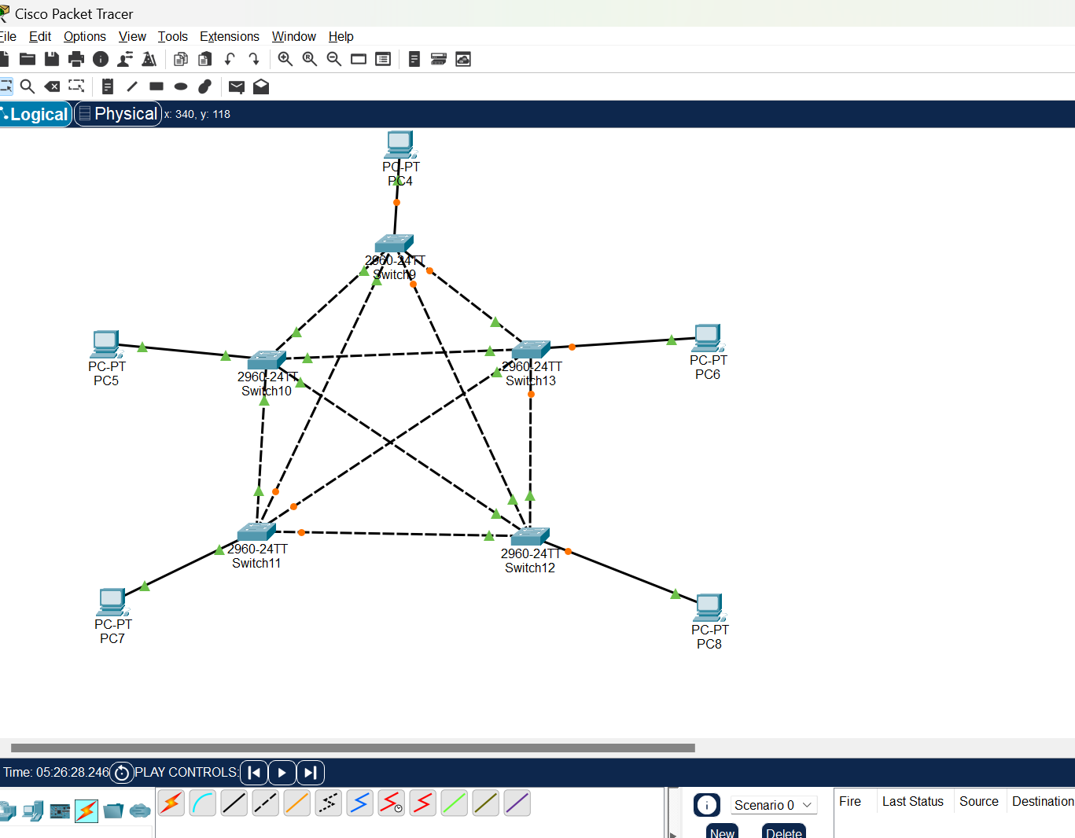

**Step 5: Assign IP address to All PCs from 192.168.1.1 to 192.168.1.5 .**

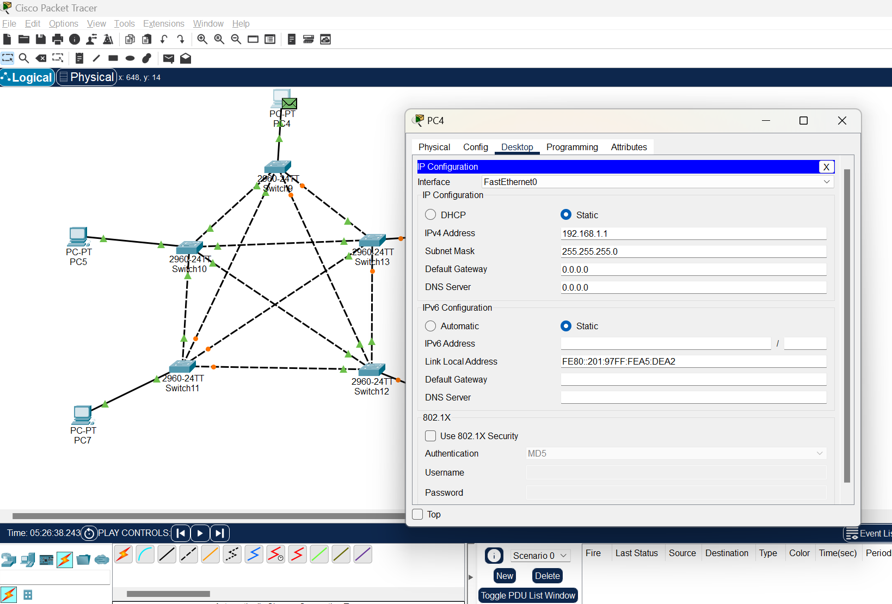

**Step 6: Take a Simple PDU and select source and destination and do the simulation; observe the behavior.**

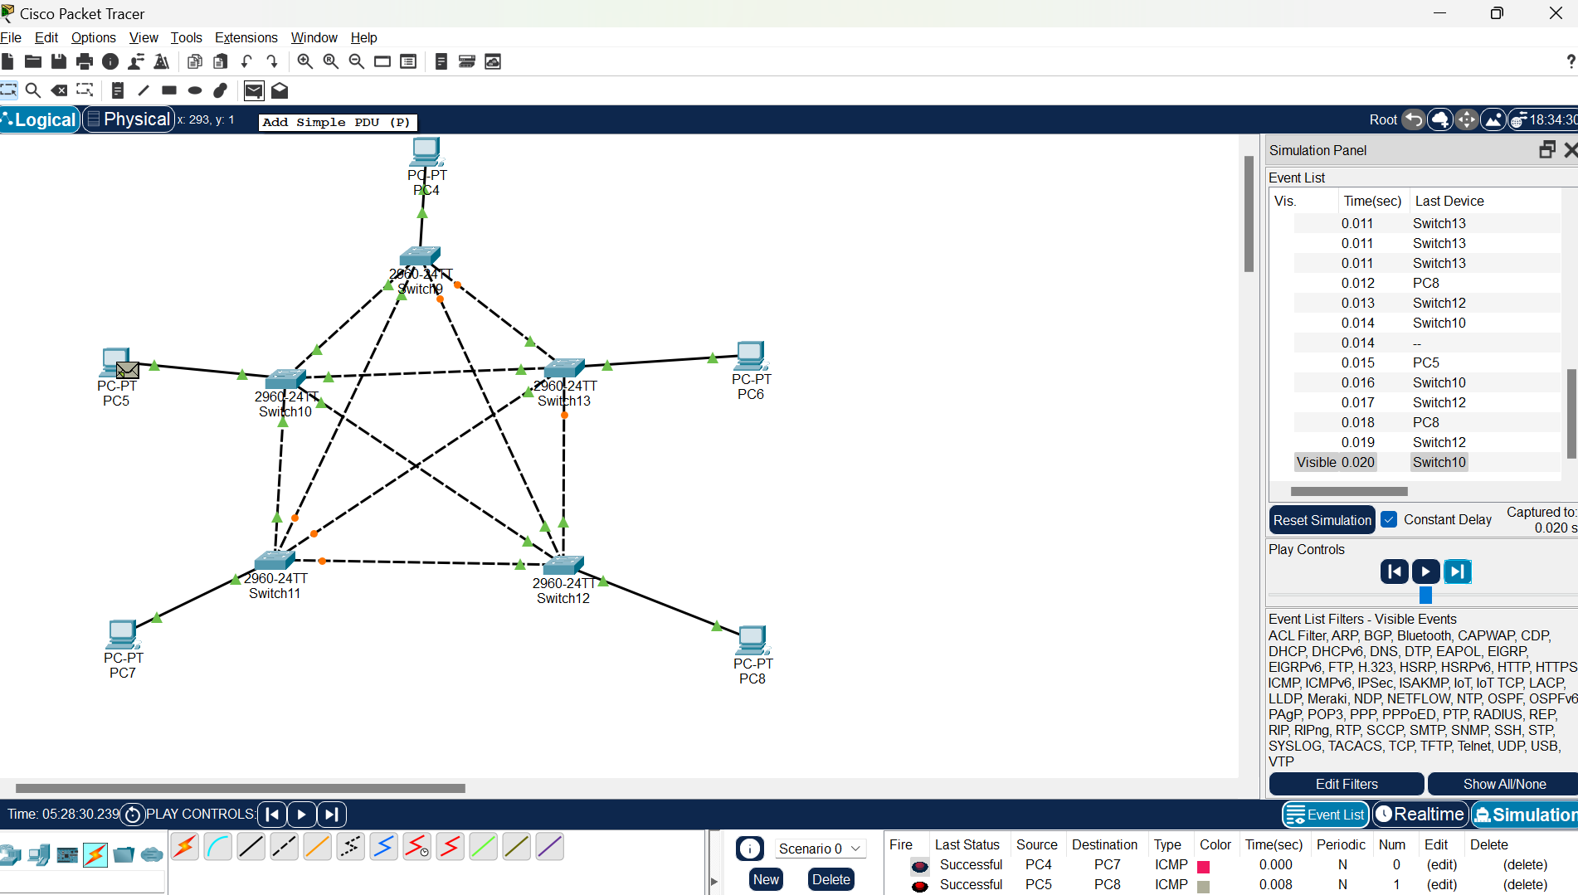

**Designing of Ring topology.**

**Step 1 : Put 8 PCs in ring form as shown in the screenshot.**

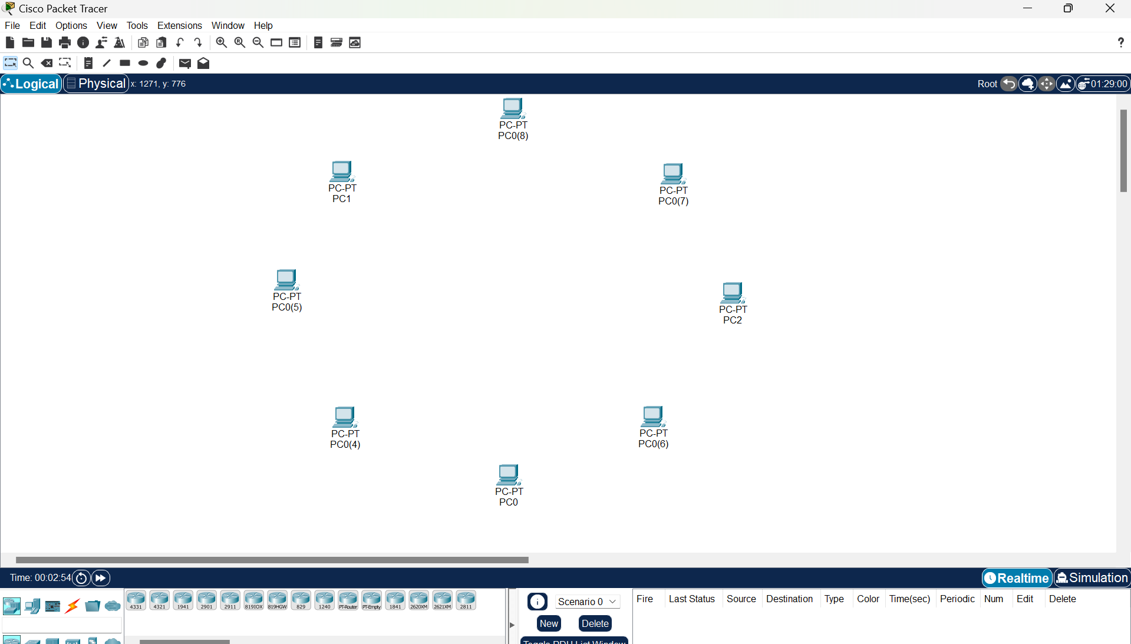

**Step 2: Put 8 switches respective to each PC as shown in the screenshot.**

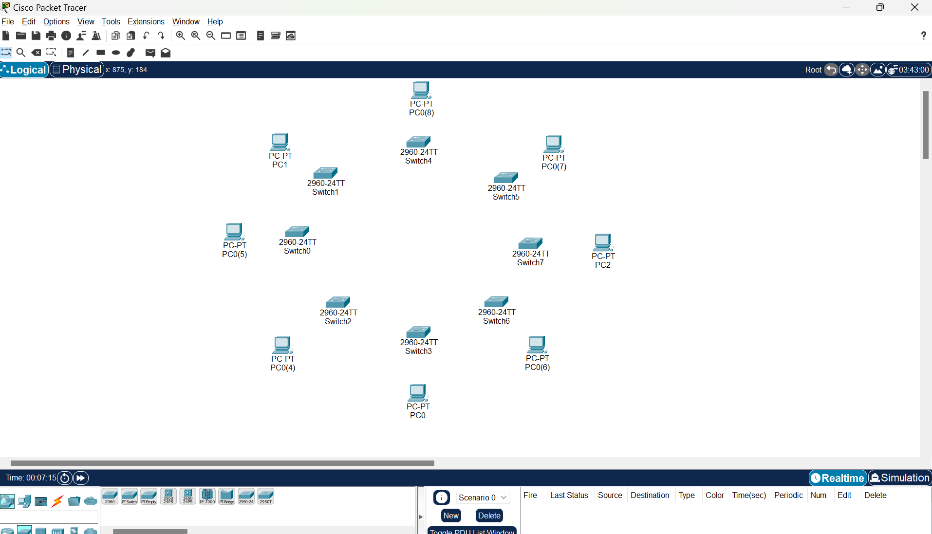

**Step 3 ; Connect all switches in ring form with cross cable.**

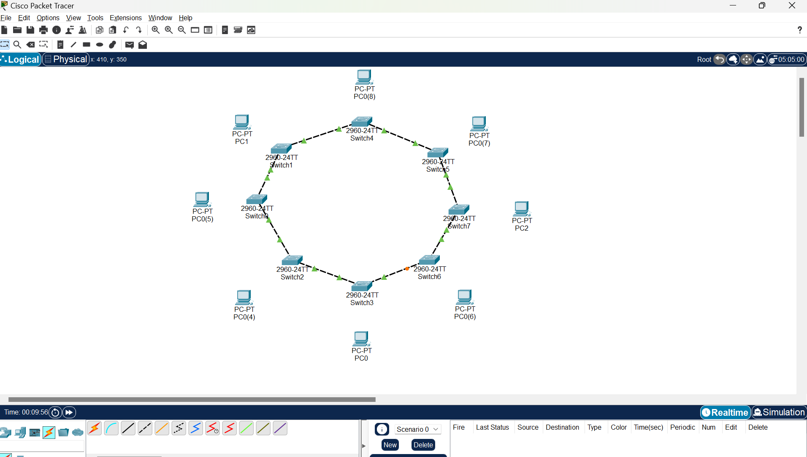

**Step 4: Connect all switches to their respective PCs with a straight cable.**

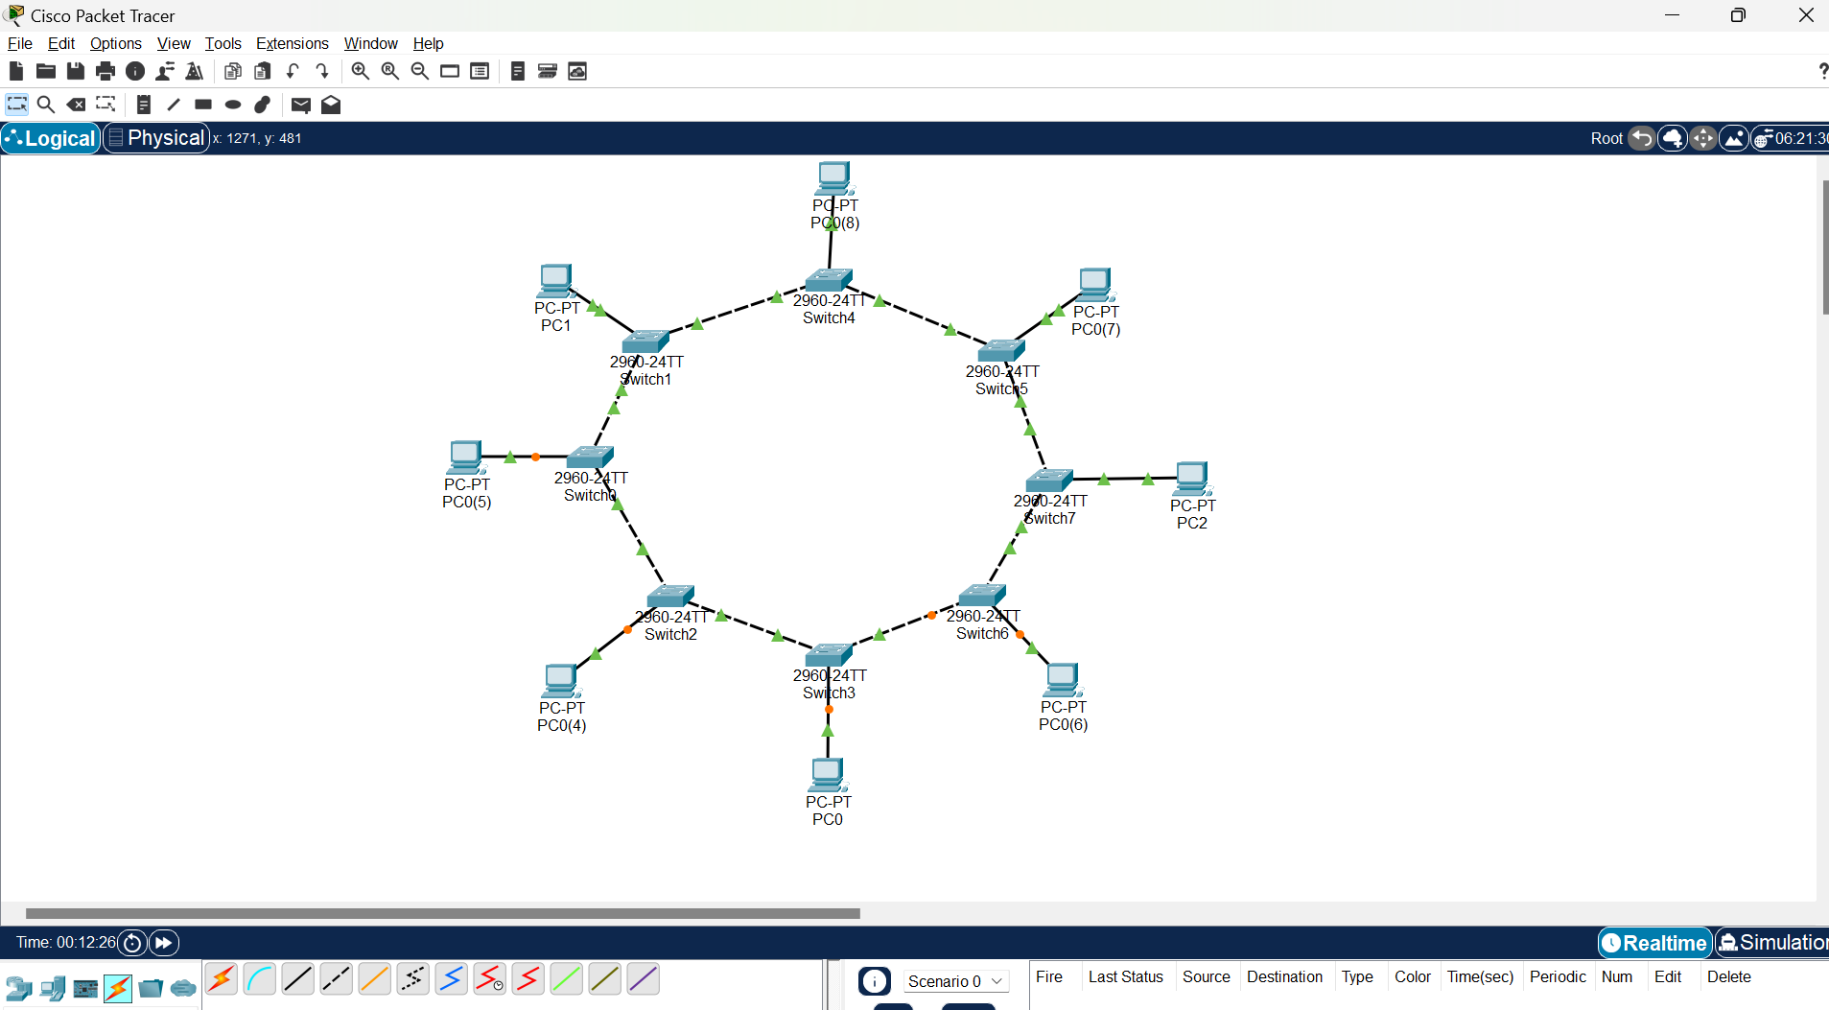

**Step 5: Assign IP address to Each PCs 192.168.0.1 to 192.168.0.8**

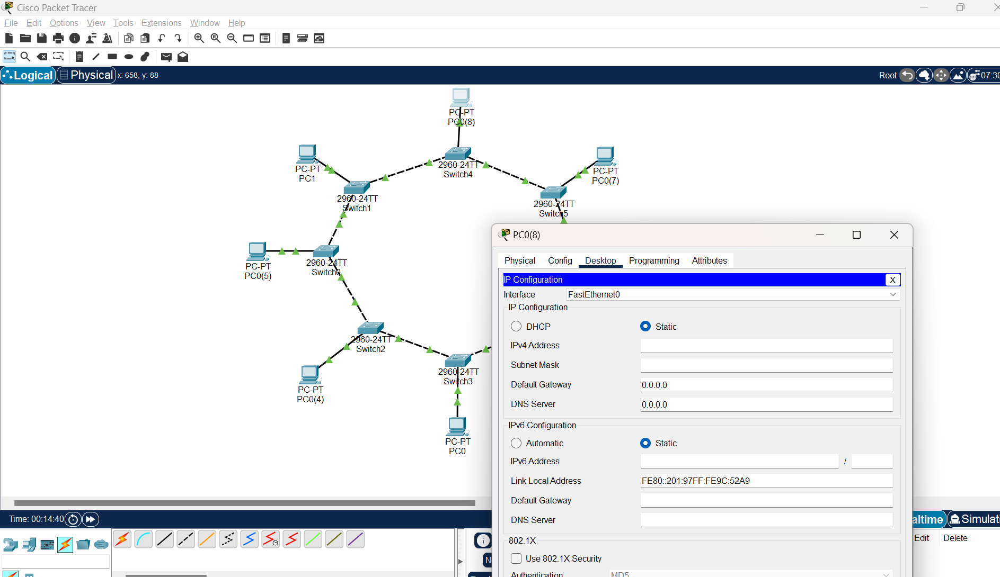

**Step : Take simple PDU and select the source and destination ,the do the simulation and observe the behavior.**

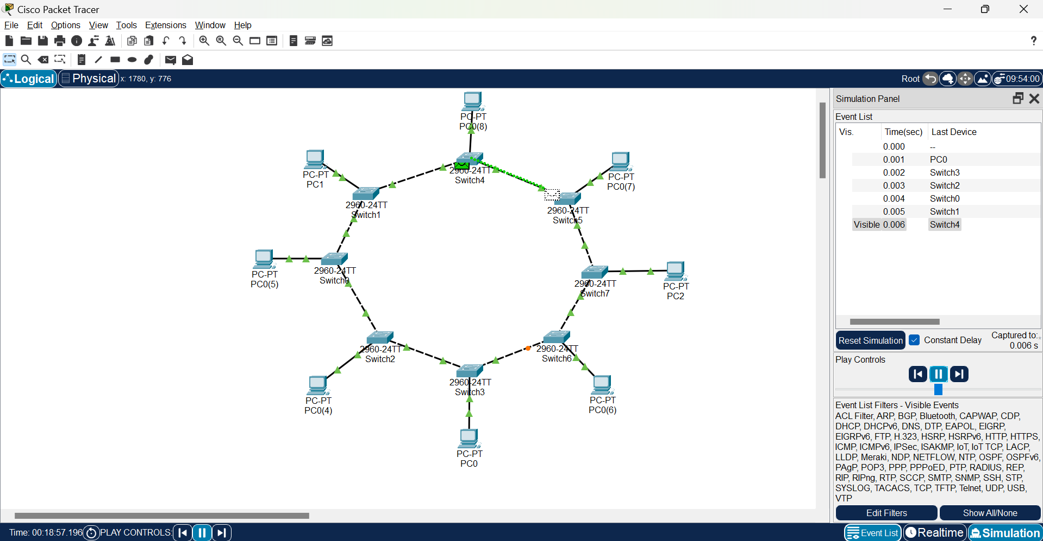

# EXPERIMENT-7

### Aim: Creating a simple Topology using a Router in Cisco Packet Tracer

**Learning objective:**

**At the end of the session, Student will be able to create Topology using a Router in Cisco Packet**

**Step 1: Place 1 router and 2 switches on the design panel, as shown in the figure below, and change their names.**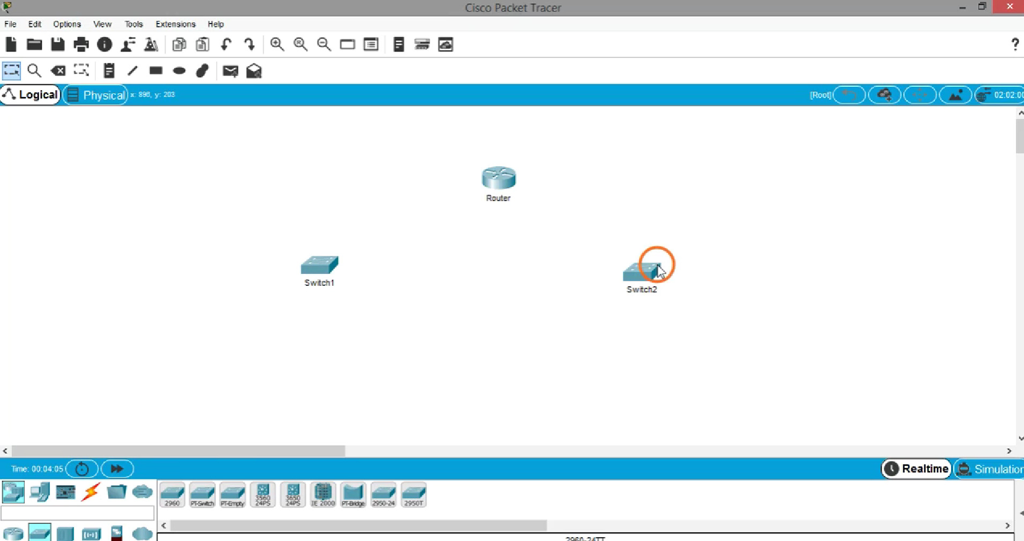

**Step 2: Place 3 PC for each switch on the design panel, as shown in the figure below, and change their names.**

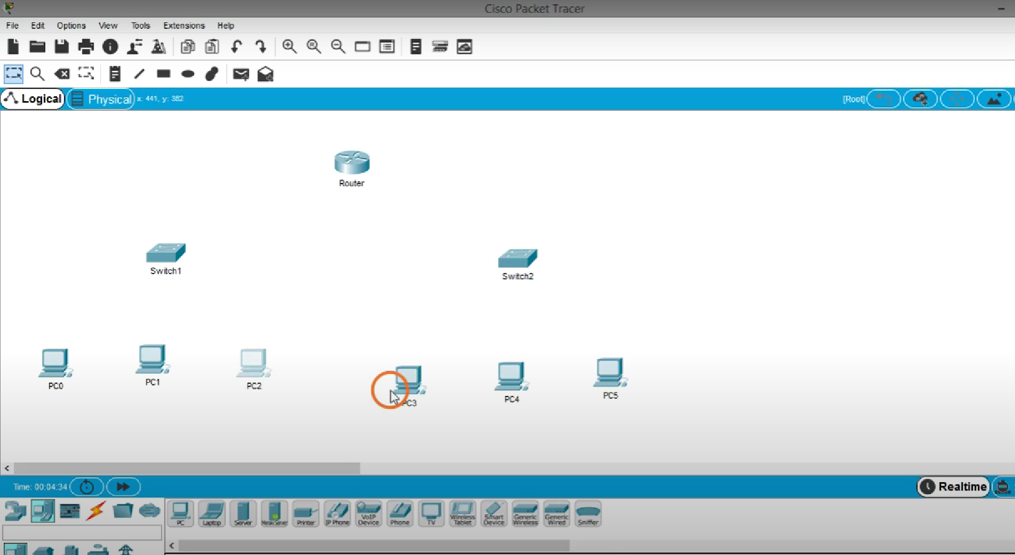

**Step 3: Now connect the arrangement with a suitable cable. as shown in the figure below.**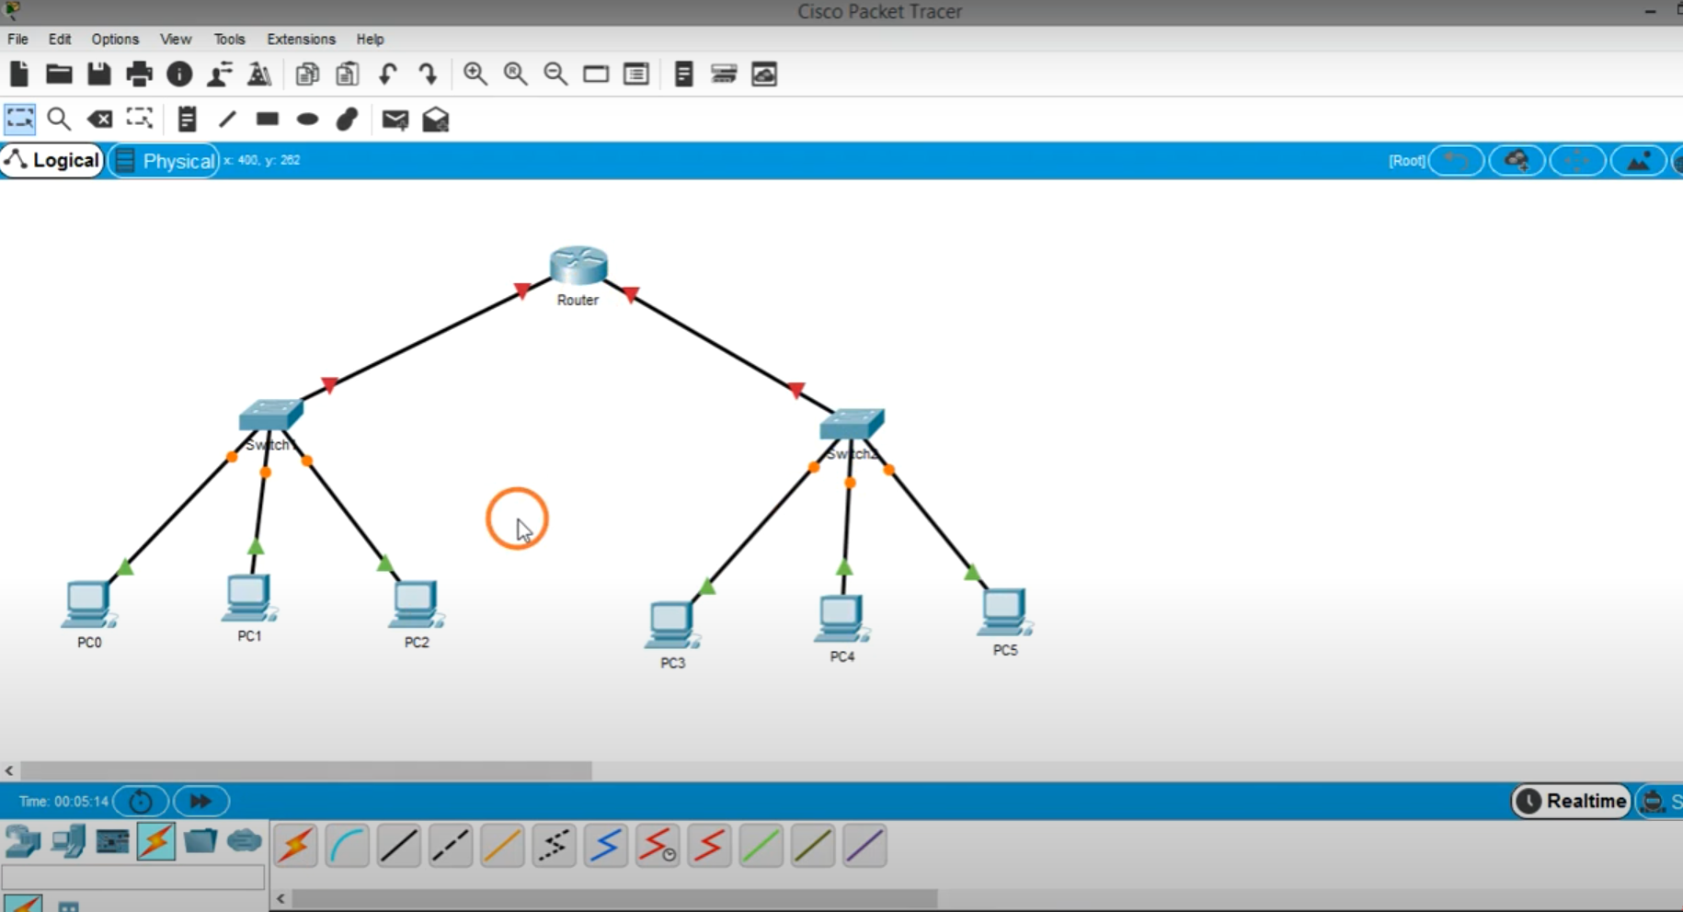

**Step 4: To show the 2 different networks, just place a rectangular boundary as shown in the figure below and tag each network by Name LAN1 And LAN 2**

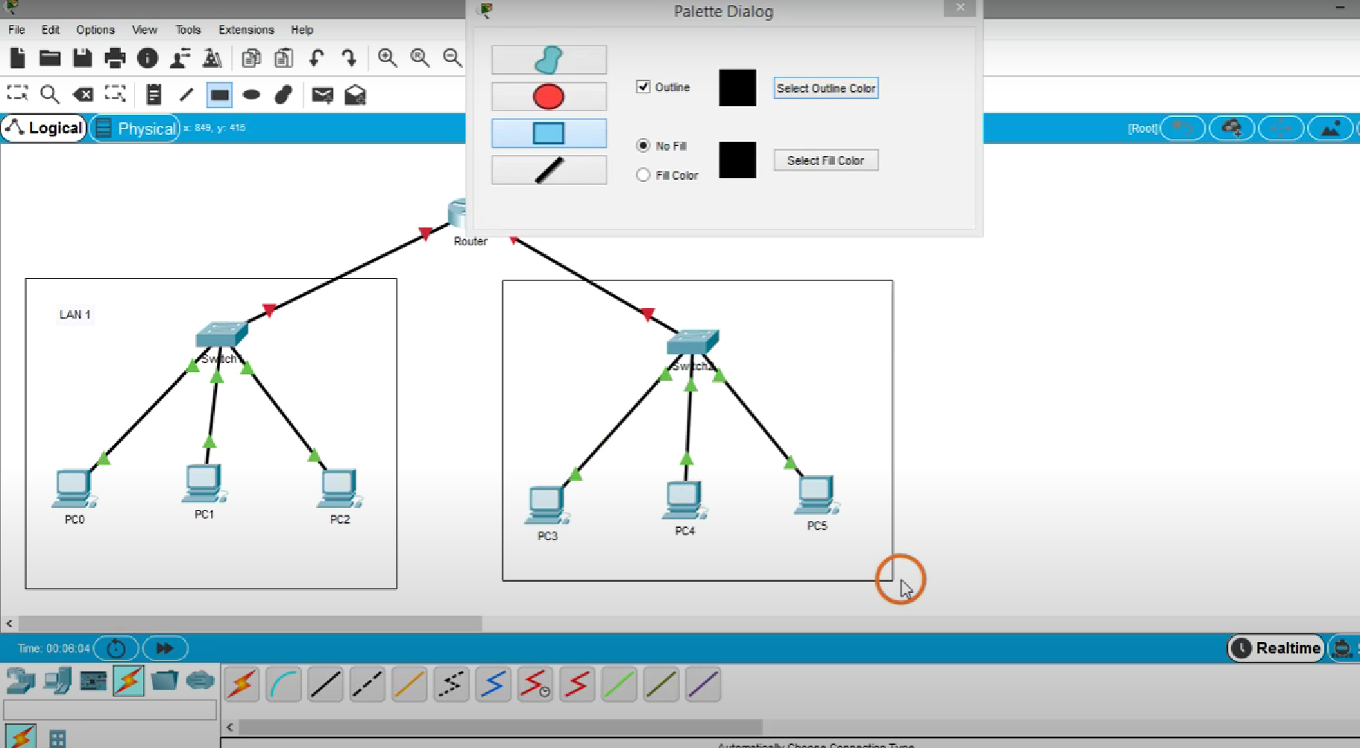



**Note-> As you can see the connection from the route to the switch shows red triangles just because yet we have not configured the router.**

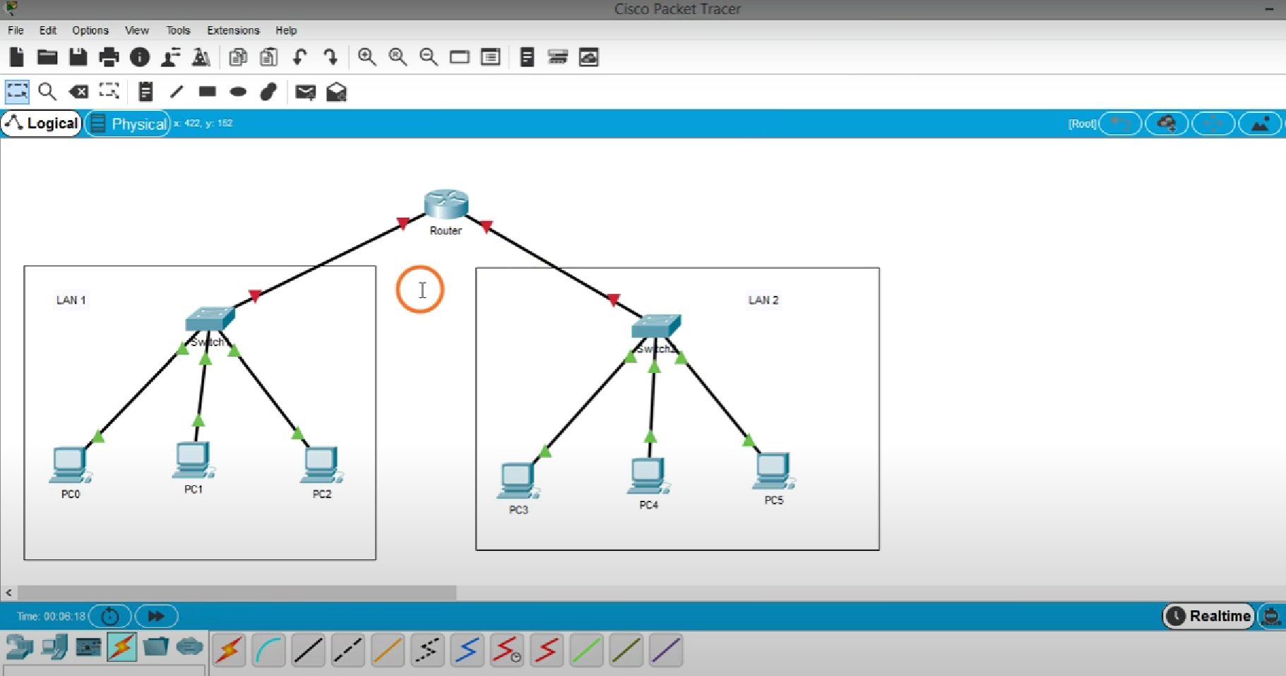



**Step 5: To configure the router, just click on the router then go to the “config: tab. then click Gigabit Ethernet 0/0**

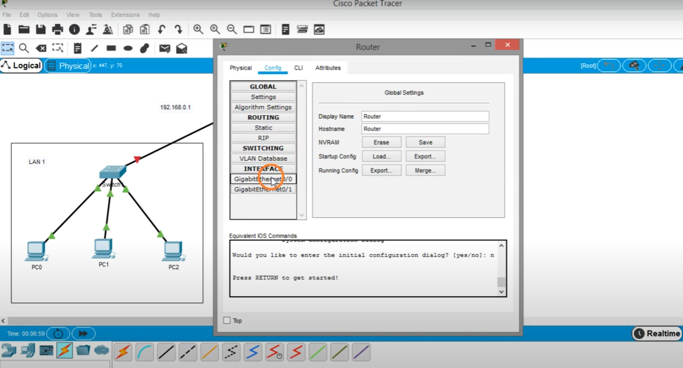

**Step 6.1: Now Give the IP address 192.168.0.1 for left side Network (subnet mask automatically appears) as shown in the figure.**

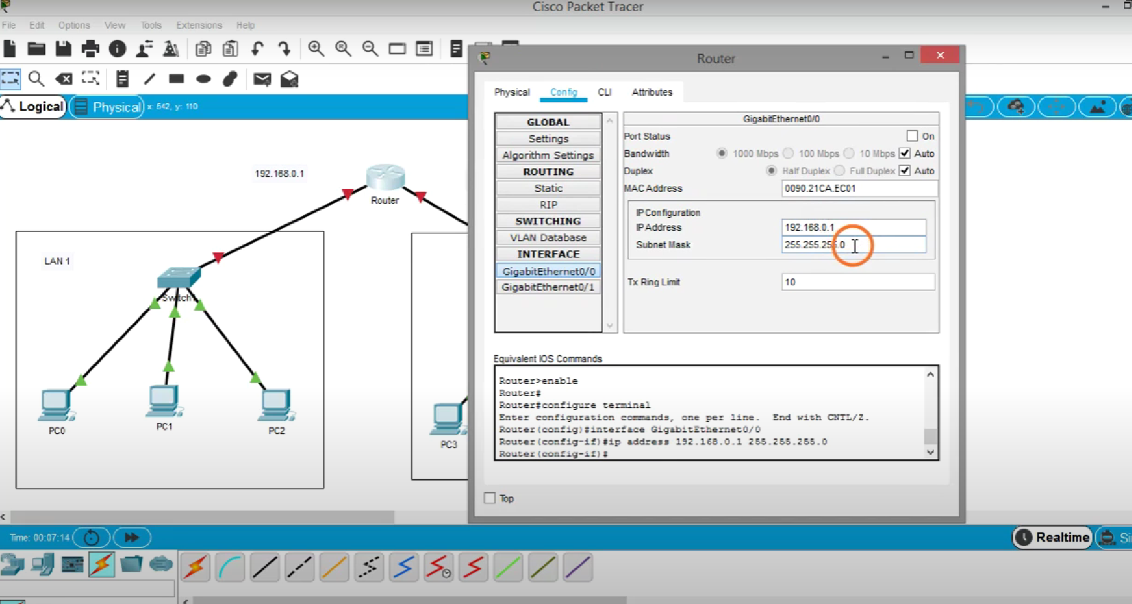

**Step 6.2 Now tick the check box “PORT STATUS” to on As shown in the figure.**

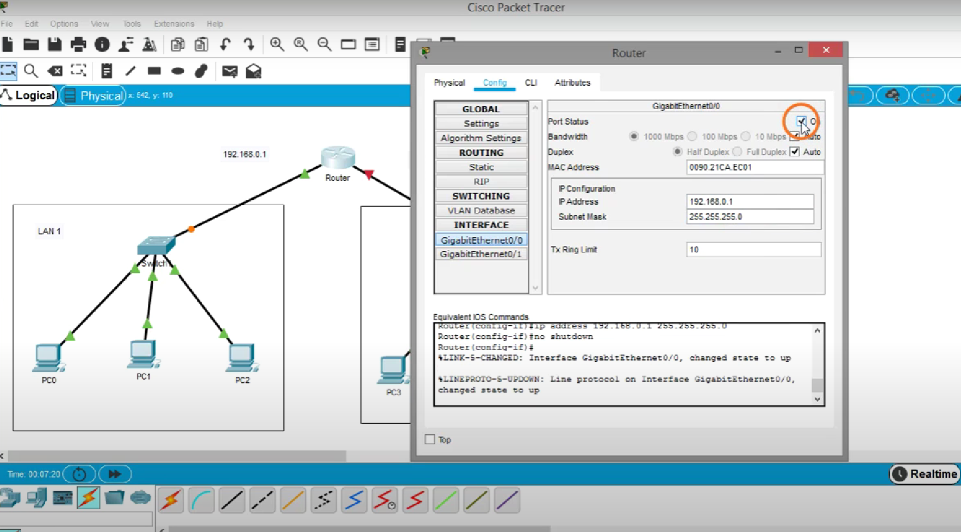

**Step 7: Similarly assign the IP Address 10.0.0.1 for right side Network, by assigning the IP address**

**Gigabit Ethernet 0/1 as step 6.**

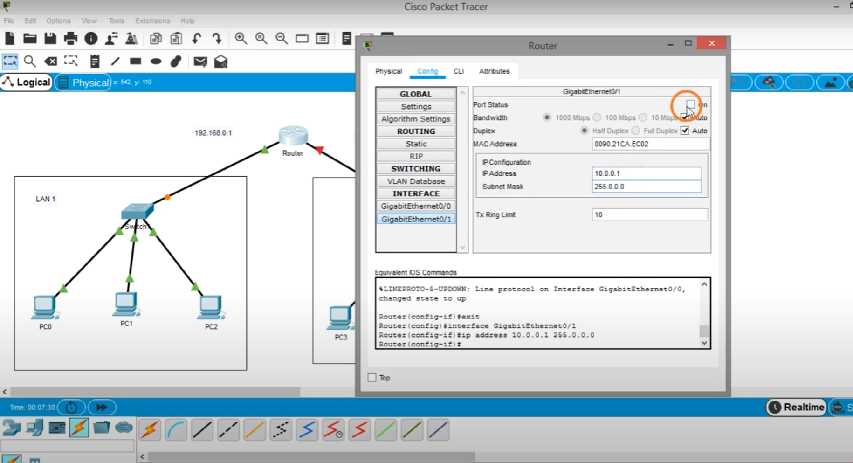

**Note 🡪 Now it has been observed the red triangles on the connections will appear green.**

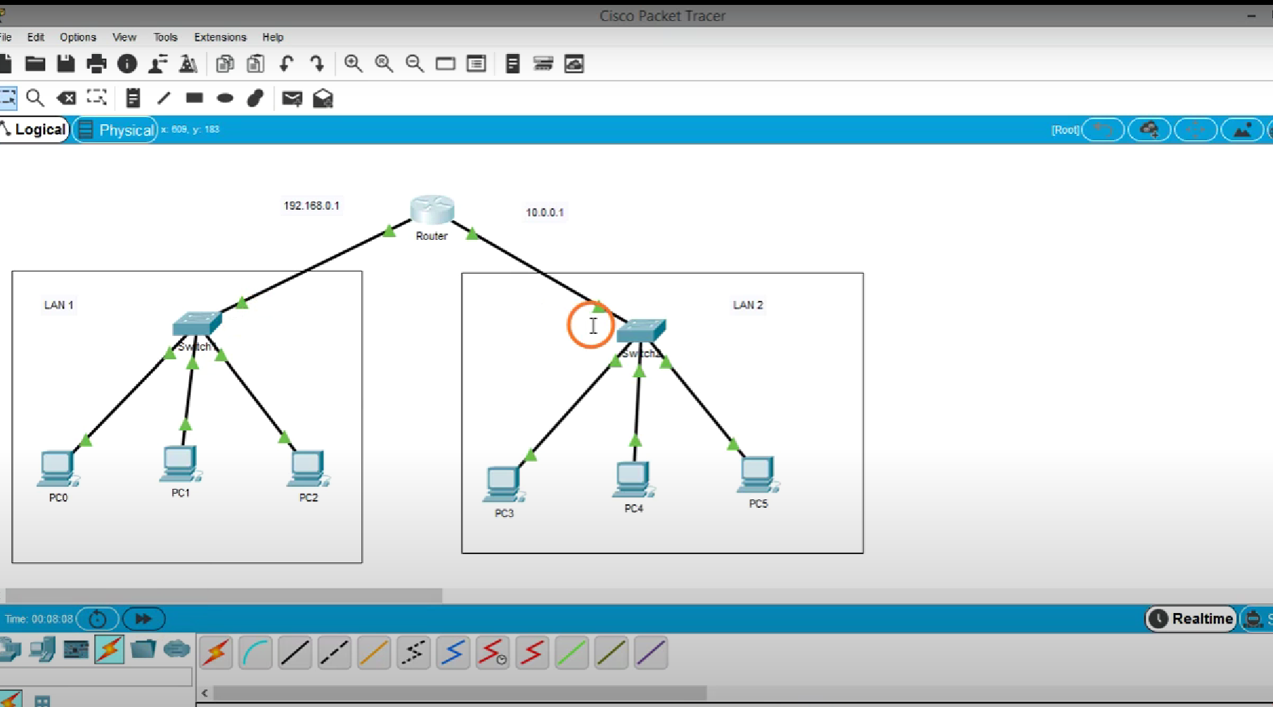



**Step 8.1 : Now assign the IP addresses to LAN1’ PC’s ( Left side Network) from 192.168.0.2 to 192.168.0.4. and assign default gateway to each LAN1’s PC, IP ofGigabyteEthernet0/0 of router i.e 192.168.0.1 as shown in figure**

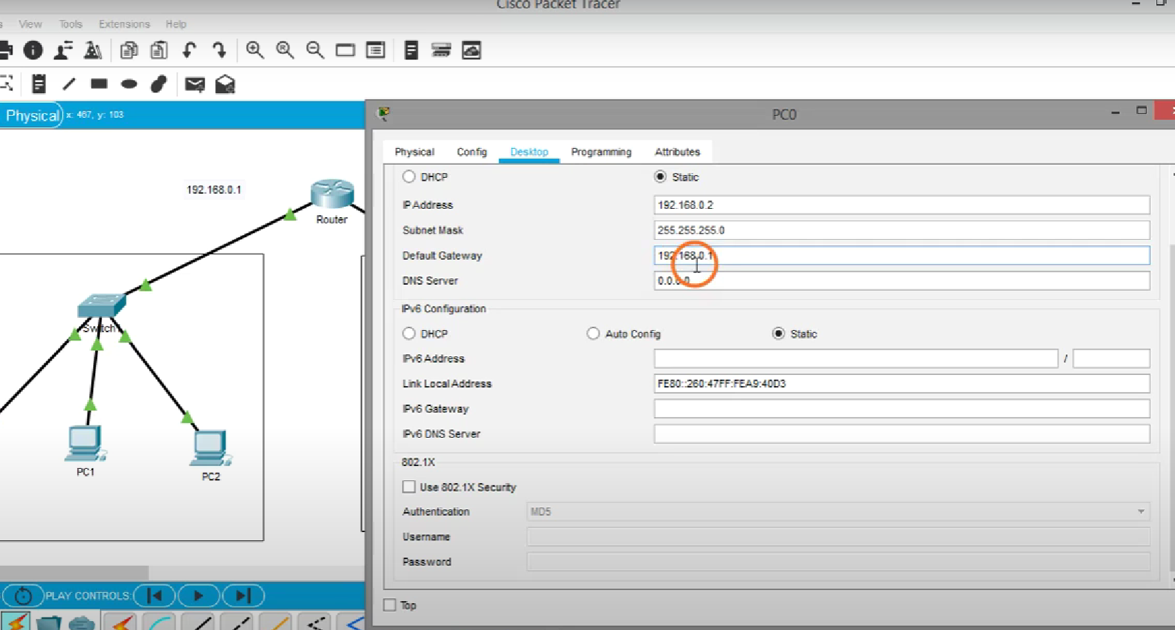

**Step 8.2: Similarly assign the IP addresses to LAN2’ PC’s ( Right side Network) from 10.0.0.2 to 10.0.0.4 and assign default gateway to each LAN2’s PC, IP ofGigabyteEthernet0/1 of router i.e 10.0.0.1 as shown in figure.**

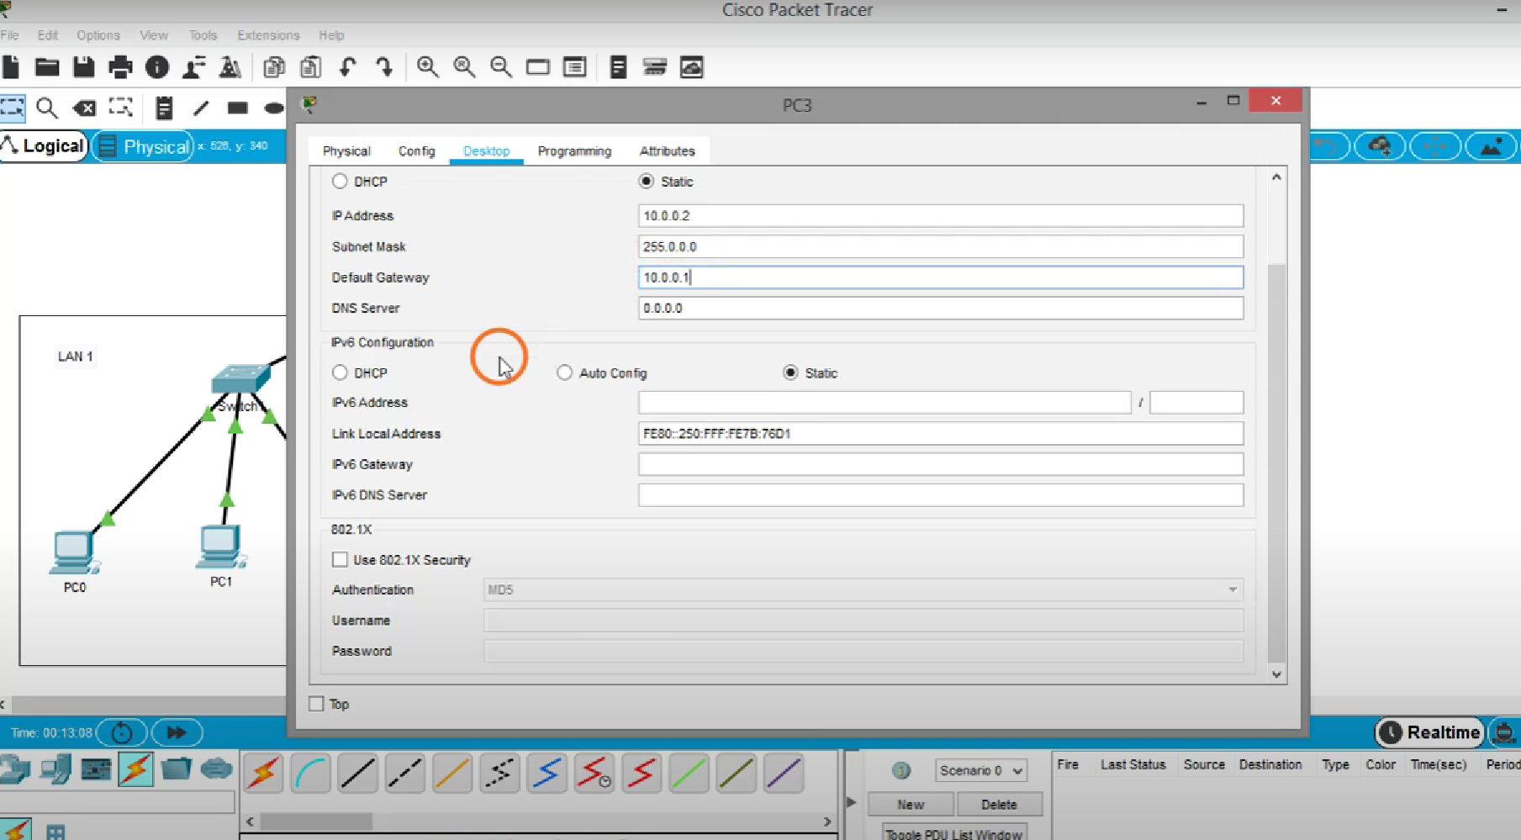

**Step 9: Now Take a simple PDU and select the ANY source (Any PC) from LAN1 and select the destination (any PC ) from LAN 2. And observe the step-wise simulation.**

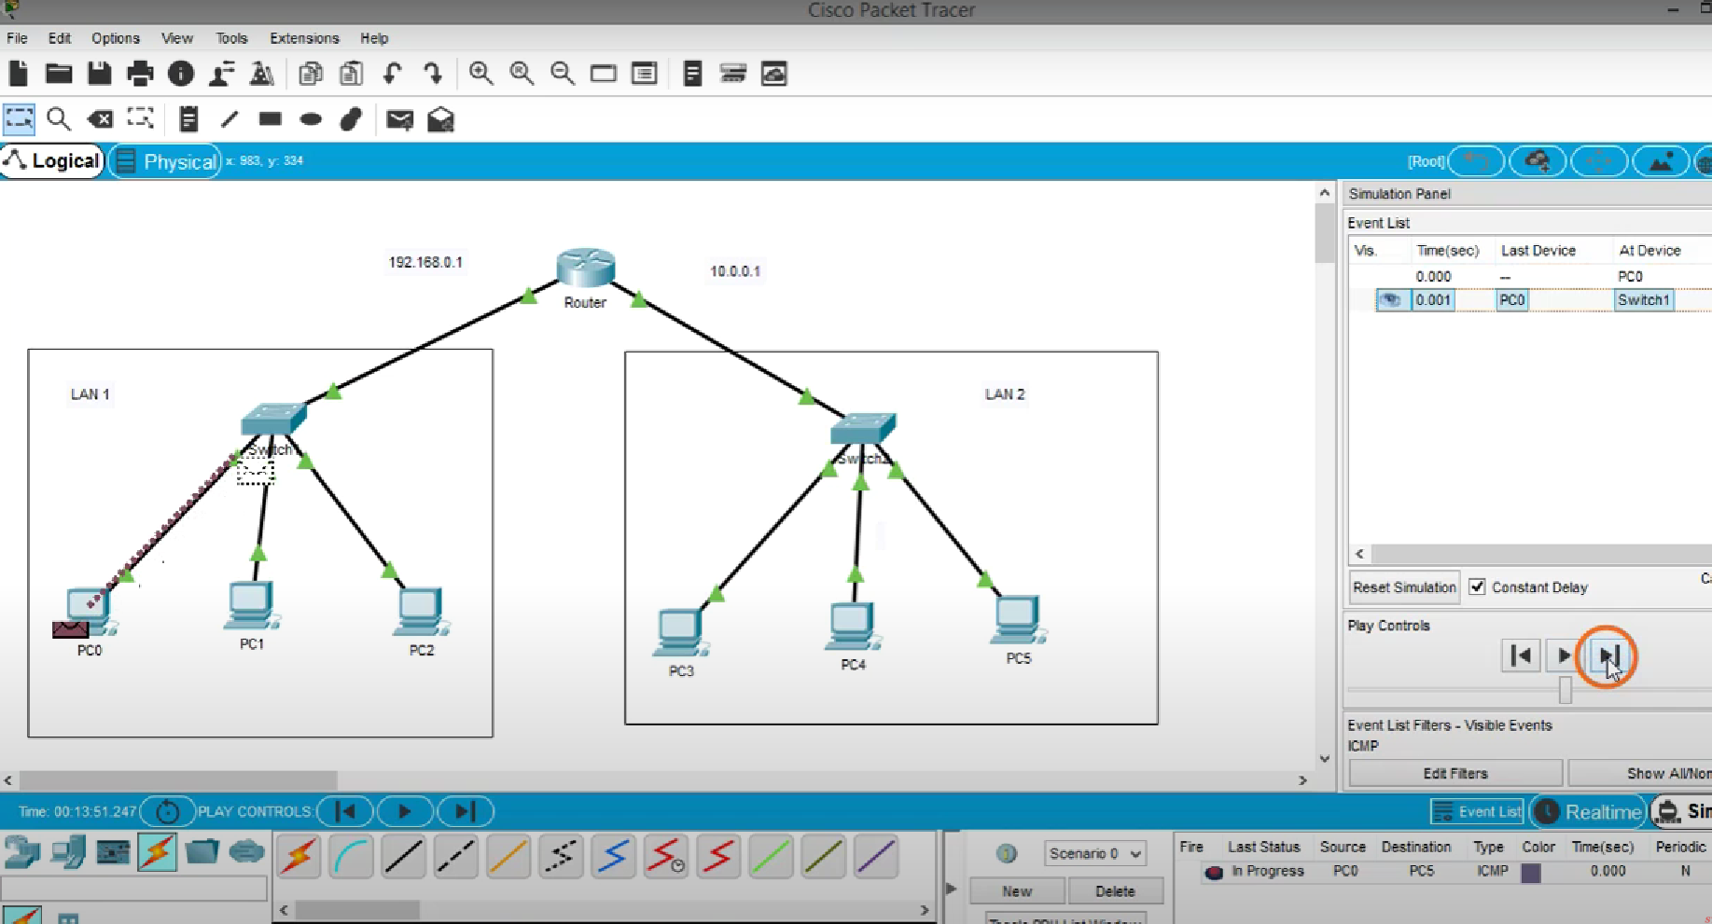



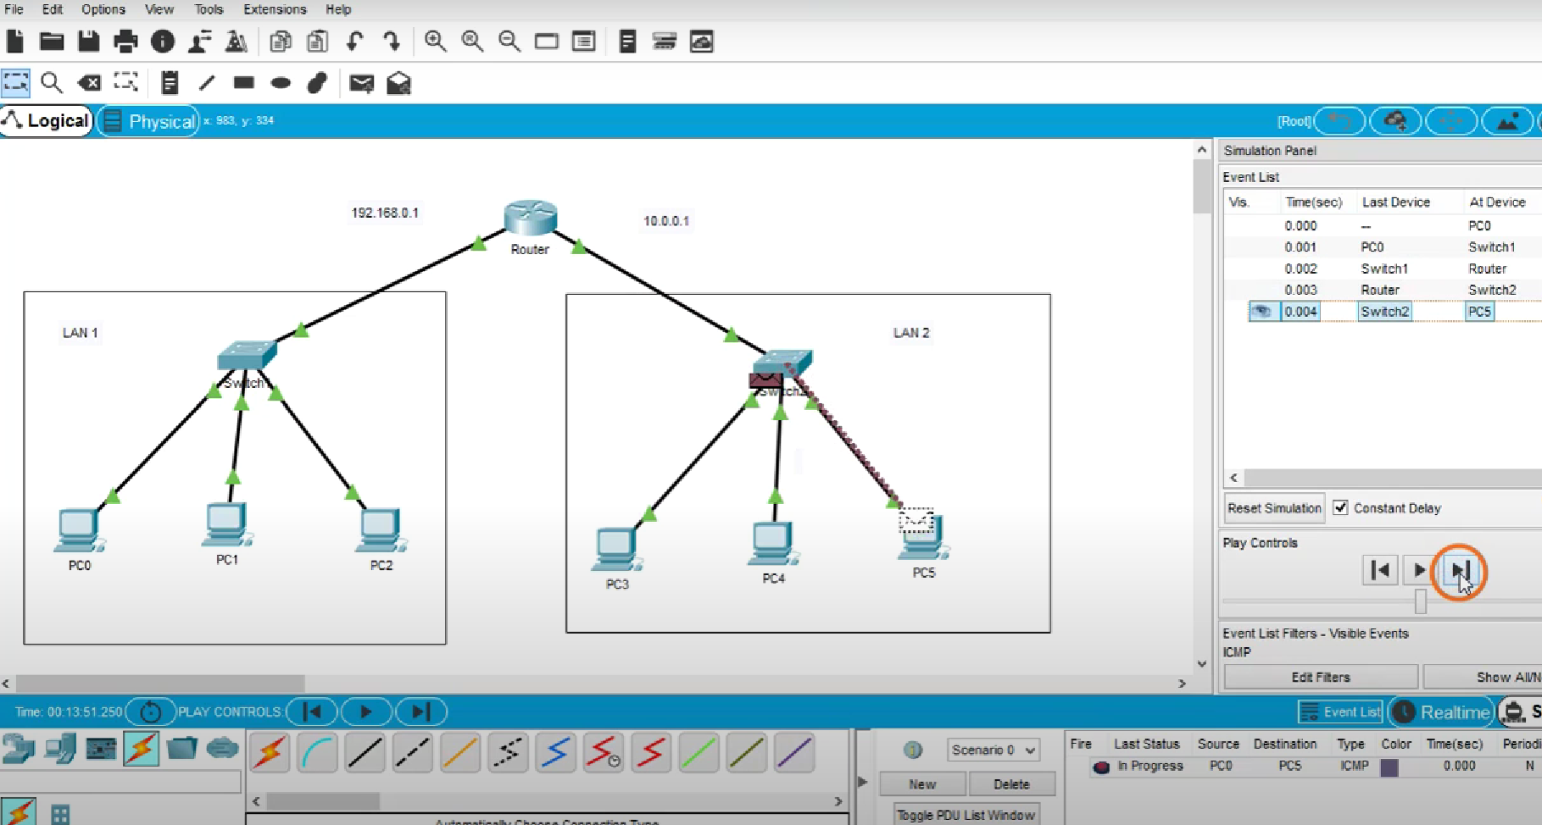



# EXPERIMENT-8

### Aim: Configuring DHCP on a Server in Cisco Packet Tracer

**Learning objective:**

**At the end of the session, the Student will be able to Configure DHCP on a Server in Cisco Packet Tracer.**

**Step 1: Make the topology as practical no 7 as shown in the figure below and make connections only (don’t assign IP address to PC’s, as DHCP will assign IP to PC’s Dynamically; it is the practical)**

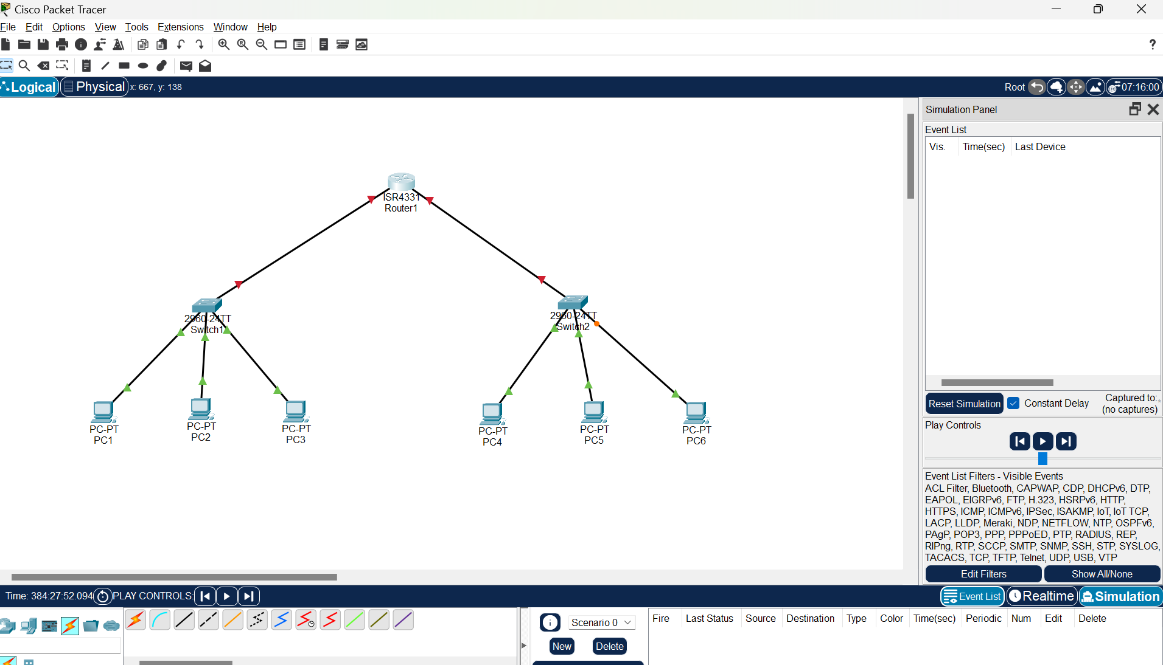

**Step2: Now configure the router the same as practical 7 for the left and right network ( i.e for left LAN 198.168.0.1 and for right 10.0.0.1)**

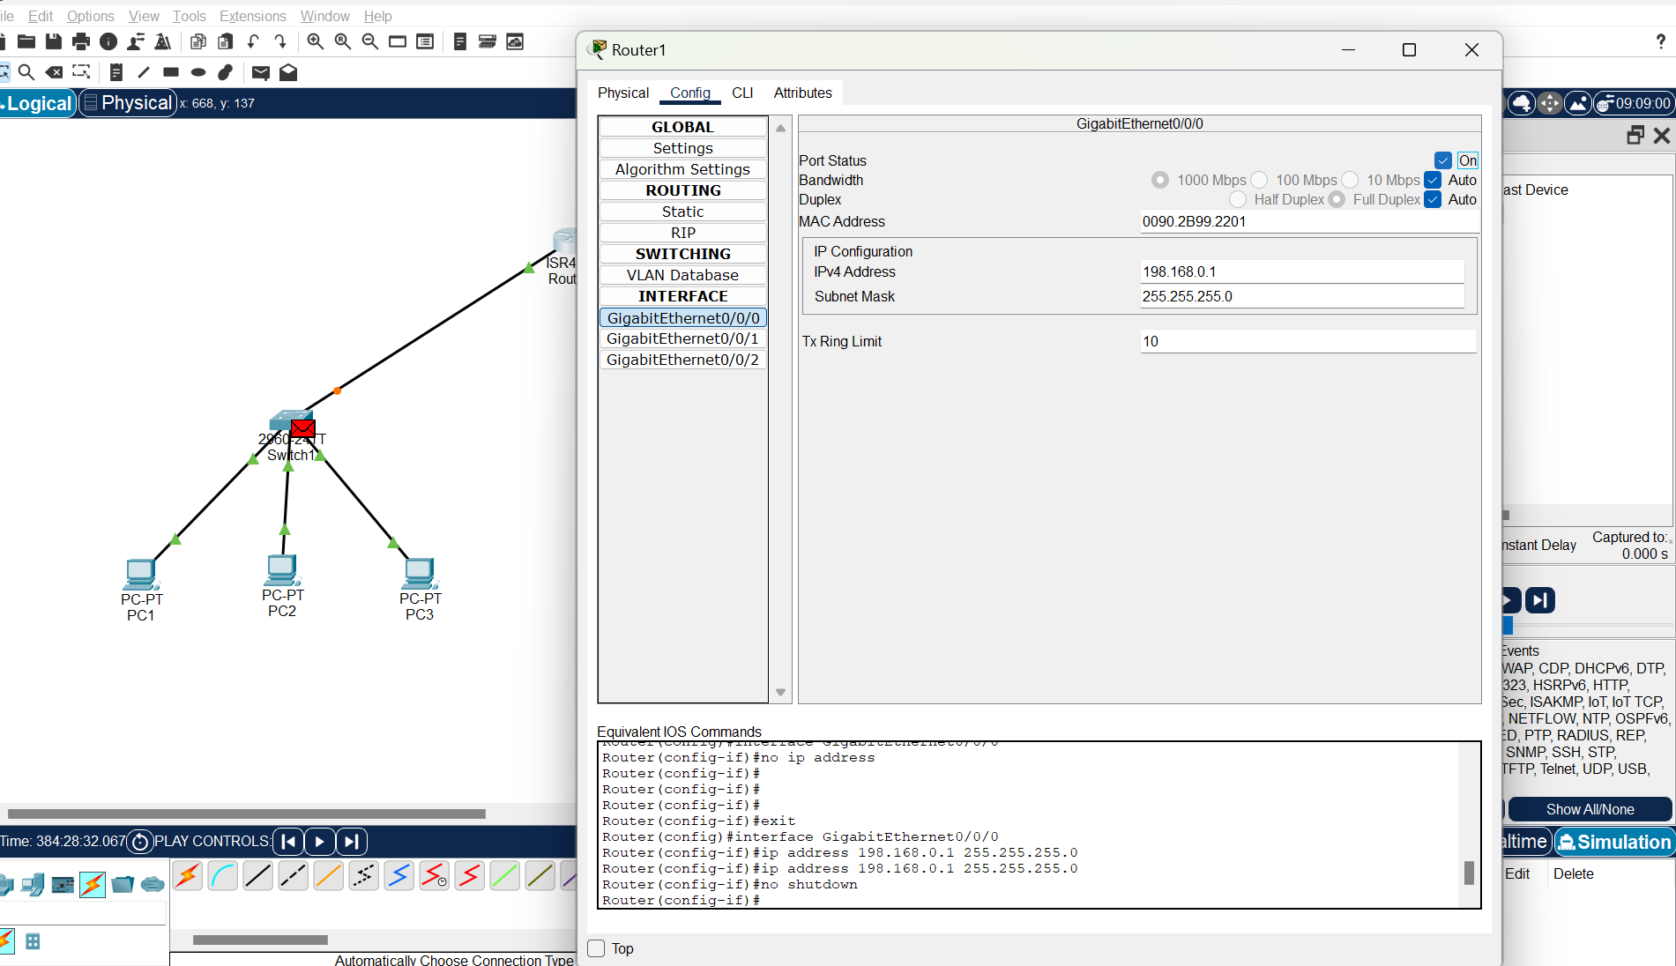



**Step 3: After configuring the router let's configure the DHCP on the router. For this click on router and go to the CLI tab (which is the command prompt for the router) As shown in the figure.**

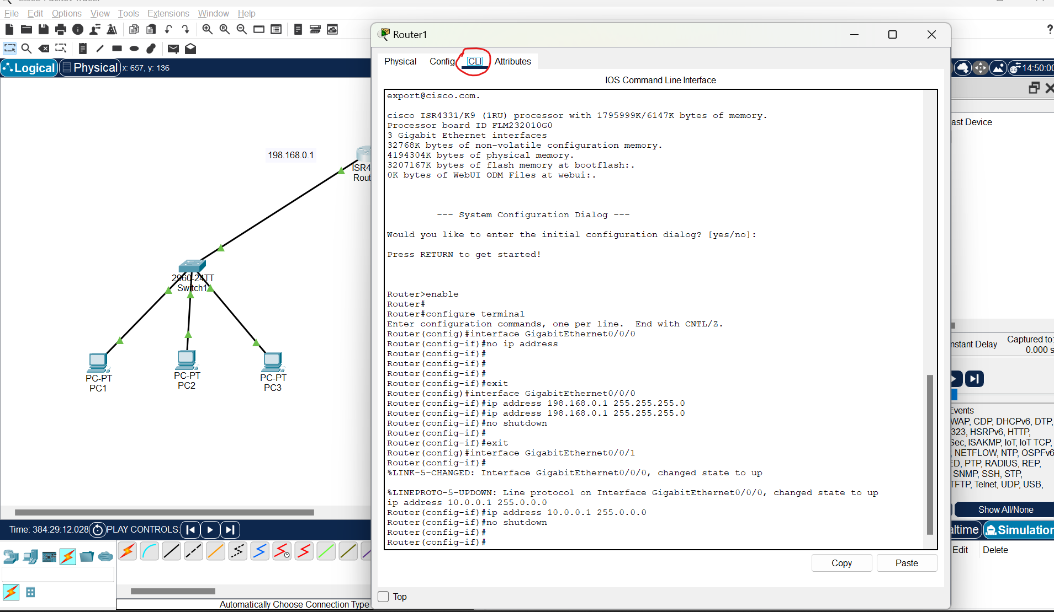

**Step 4: On CLI write the following command for right network and left network. As shown in figure; commands are in the red rectangle (you just zoom in) also given below the figure(mind the space while writing commands). After executing the command just close the CLI window**

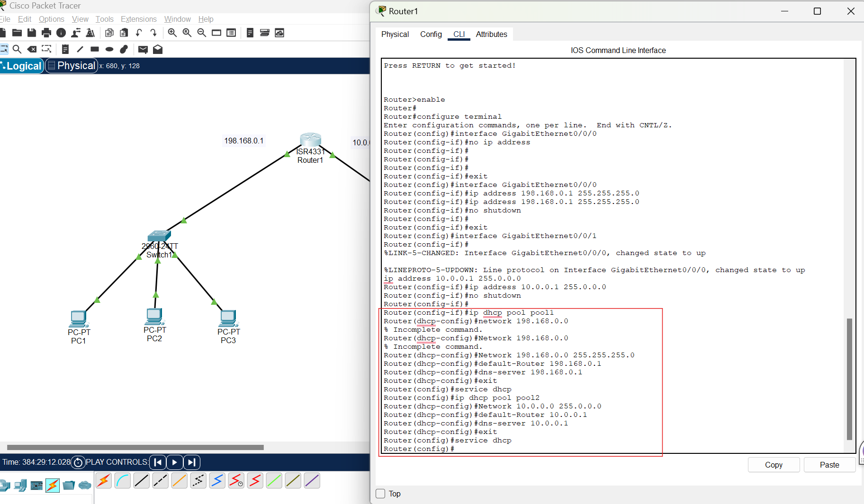

Router(config-if)#ip dhcp pool pool1

Router(dhcp-config)#Network 198.168.0.0 255.255.255.0

Router(dhcp-config)#default-Router 198.168.0.1

Router(dhcp-config)#dns-server 198.168.0.1

Router(dhcp-config)#exit

Router(config)#service dhcp

Router(config)#ip dhcp pool pool2

Router(dhcp-config)#Network 10.0.0.0 255.0.0.0

Router(dhcp-config)#default-Router 10.0.0.1

Router(dhcp-config)#dns-server 10.0.0.1

Router(dhcp-config)#exit

Router(config)#service dhcp

Router(config)#

**Step 5: Now assign the IP to PC’s dynamically for that click on PC and go to the IP configuration (As in previous practicals) and click on DHCP radio button**

**, you will see it requesting IP automatically Soon after requesting it will assign automatic IP as shown in figure 2**

**. As shown in figure below**

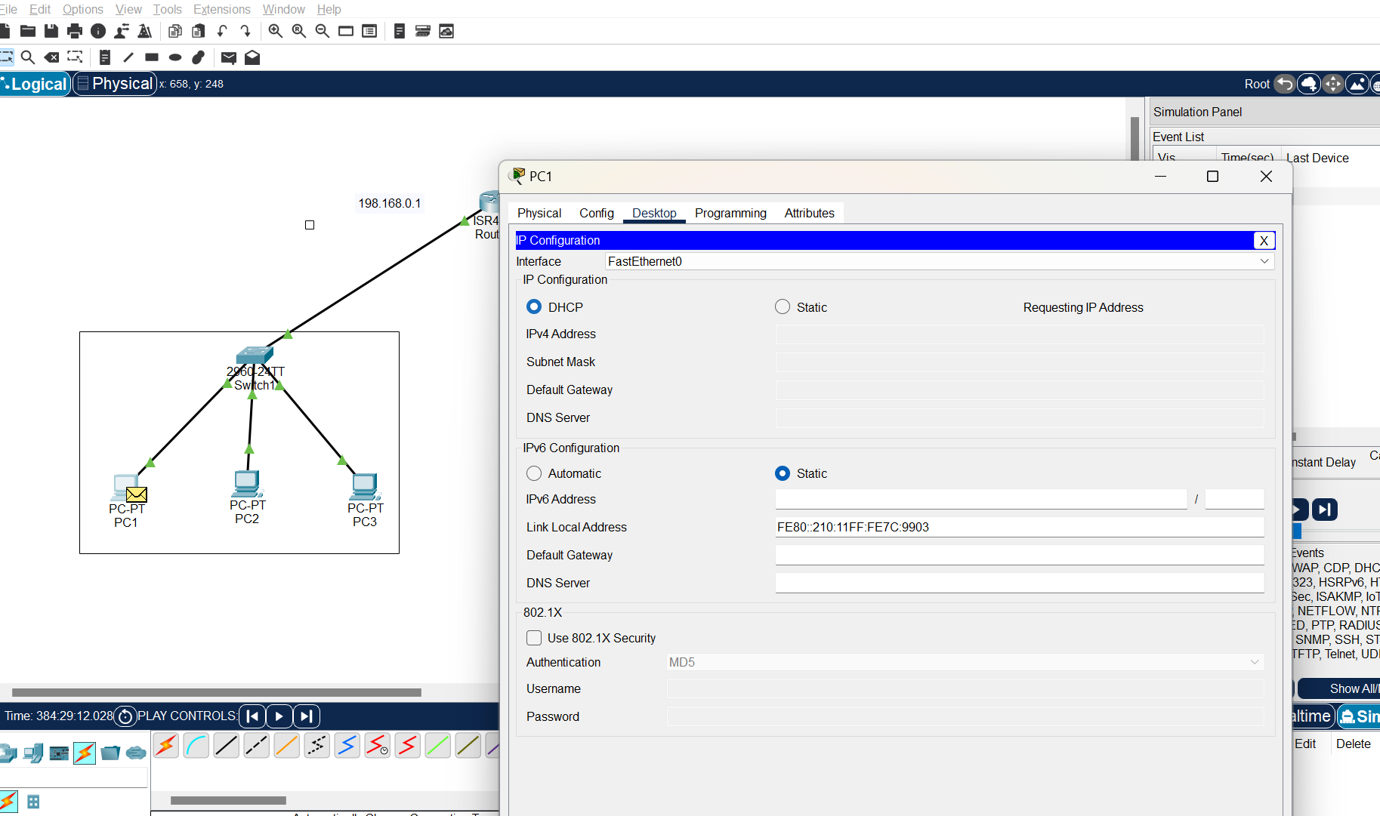



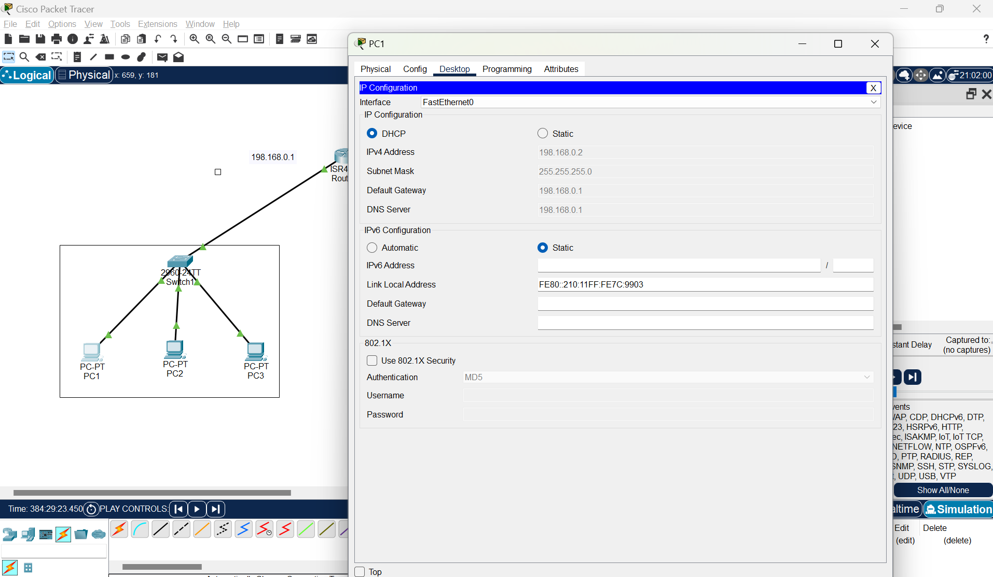



**Step 6 : Now select the source PC and destination PC by adding PDU and observe the simulation.**

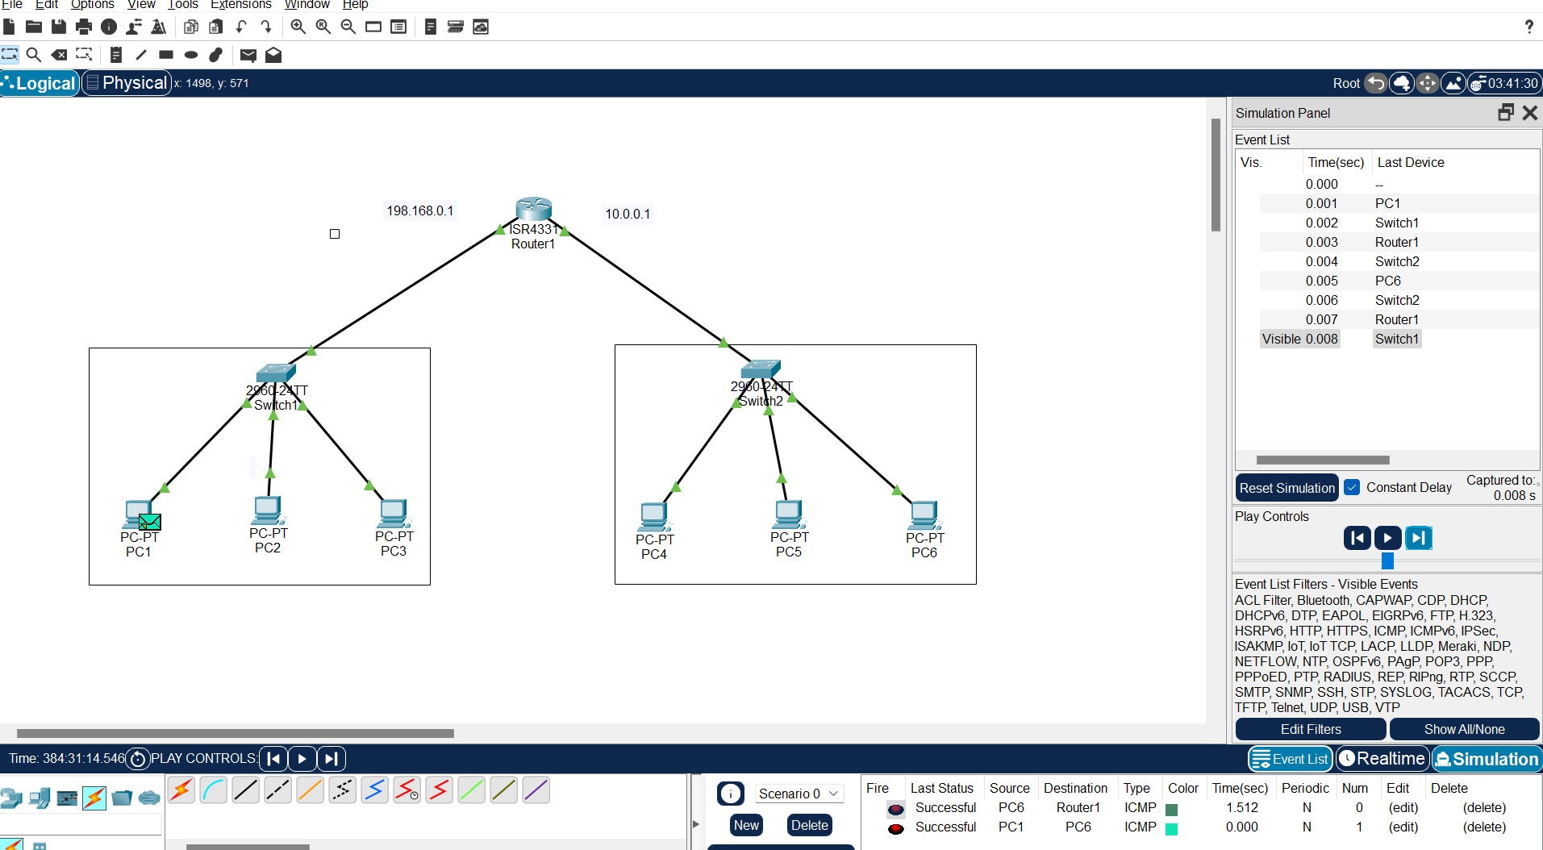



# EXPERIMENT-9

### Aim: Implement bit stuffing and de-stuffing.

**Learning objective:**

**At the end of the session, the Student will be able to Implement bit stuffing and de-stuffing.**

#include<stdio.h>

#include<conio.h>

#include<string.h>

void main()

{

char in[100],out[100],des[100],flag[9]="01111110";

int inlen, i, j, count=0,k,outlen,len;

clrscr();

printf("Enter the data to be bit stuffed:\n");

gets(in);

inlen=strlen(in); // “strlen” finds the length of the string

strcpy(out,flag);

for(i=0,j=8;i<inlen;i++)

{

if(in[i]=='1')

count++;

else

count = 0;

out[j++]=in[i];

if(count == 5)

{

out[j++] = '0';

count = 0;

}

}

out[j] = '\0';

strcat( out, flag);

printf("The bit stuffed frame is:\n %s",out);

getch();

outlen=strlen(out);

len=(outlen-8);

count=0;

for(k=0,j=8;j<(outlen-8);j++)

{

if(out[j]=='1')

count++;

else

count=0;

des[k++]=out[j];

if(count == 5)

{

des[k]=out[j++];

count=0;

}

}

des[k]='\0';

printf("\nThe destuffed frame is: %s \n",des);

getch();

}

Result:

Enter the data to be bit stuffed: 11111

The bit stuffed frame is: 01111110 11111 0 01111110

The destuffed frame is: 01111110 11111 01111110

# EXPERIMENT-10

### Aim: Write a program for hamming code generation for error detection and

### correction.

**Learning objective:**

**At the end of the session, the Student will be able to write the program for hamming code generation for error detection and correction.**

#include <stdio.h>

#include <math.h>

int main() {

   int data[10];

   int data_at_reciever[10];

   int c,c1,c2,c3,i;

   printf("Enter 4 bits of data one by one\n");

   scanf("%d", &data[0]);

   scanf("%d", &data[1]);

   scanf("%d", &data[2]);

   scanf("%d", &data[4]);

   //Calculation of even parity

   data[6] = data[0] ^ data[2] ^ data[4];

   data[5] = data[0] ^ data[1] ^ data[4];

   data[3] = data[0] ^ data[1] ^ data[2];

   printf("\nEncoded data is\n");

   for (i = 0; i < 7; i++) {

       printf("%d ",data[i]);

   }

   return 0;

}